SUSTAINABLE CORROSION PROTECTION OF MARINE STEEL USING PF-115 COATINGS MODIFIED WITH NANOCALCITE, ZnO AND Cu₂O
Natalya Fatyanova
Azerbaijan State Marine Academy, Baku, Azerbaijan

Abstract
Corrosion of marine steel structures remains a major challenge in shipbuilding and offshore engineering because continuous exposure to seawater accelerates material degradation, shortens service life, and increases maintenance costs. The development of sustainable protective coatings with enhanced corrosion resistance is therefore of considerable practical and scientific importance.
This study investigates the effect of progressive nanomodification of PF-115 alkyd coatings using nanocalcite (CaCO₃), zinc oxide (ZnO), and cuprous oxide (Cu₂O) for the corrosion protection of marine steel. Four coating systems were prepared, including a conventional PF-115 coating (S1) and three progressively modified formulations containing nanocalcite (S2), nanocalcite with ZnO (S3), and nanocalcite with ZnO and Cu₂O (S4). The coatings were characterized using scanning electron microscopy (SEM), energy-dispersive X-ray spectroscopy (EDS), electrochemical impedance spectroscopy (EIS), and potentiodynamic polarization measurements to establish the relationship between coating microstructure and electrochemical corrosion behaviour.
The results demonstrated a progressive improvement in protective performance with increasing nanomodification. SEM observations revealed a denser and more homogeneous coating microstructure, while EDS confirmed the incorporation of the selected nanomodifiers into the PF-115 matrix. Electrochemical measurements showed a substantial increase in charge-transfer resistance from 420 Ω·cm² for S1 to 5080 Ω·cm² for S4, accompanied by a decrease in corrosion current density from 3.26 to 0.31 μA cm⁻². These results indicate a significant enhancement in corrosion resistance resulting from the complementary action of nanocalcite, ZnO, and Cu₂O.
A corrosion protection mechanism is proposed to explain the synergistic action of the incorporated nanomodifiers. The combined effect of matrix densification, improved barrier properties, and suppression of electrochemical reactions restricts the penetration of aggressive species toward the steel substrate. The developed nanomodified PF-115 coating demonstrates considerable potential as a sustainable protective material for marine engineering and offshore applications.
Keywords: PF-115 coating; nanocalcite; zinc oxide; cuprous oxide; marine steel; corrosion protection; electrochemical impedance spectroscopy; nanomodified coatings.

1. Introduction
Corrosion is one of the principal factors limiting the durability and operational reliability of marine steel structures. Ships, offshore platforms, coastal facilities, and port infrastructure operate under continuous exposure to seawater, chloride ions, dissolved oxygen, and cyclic environmental conditions that accelerate electrochemical degradation. As a consequence, corrosion leads to substantial economic losses, increased maintenance requirements, and reduced structural safety, creating a persistent challenge for the maritime industry.
Organic protective coatings remain one of the most effective and economically viable methods for protecting steel in aggressive marine environments. Their primary function is to isolate the metallic substrate from corrosive species by forming a continuous barrier against moisture, oxygen, and chloride ions. Among commercially available alkyd coatings, PF-115 has been extensively used because of its favourable adhesion, weather resistance, ease of application, and relatively low production cost. Nevertheless, the long-term protective performance of conventional PF-115 coatings is often limited by the presence of microstructural defects and interconnected pores that facilitate electrolyte penetration during service [1-3].
Recent advances in nanotechnology have created new opportunities for improving the performance of conventional organic coatings. The incorporation of nanoscale particles into polymer matrices can reduce porosity, improve structural homogeneity, and enhance barrier properties while maintaining the technological advantages of traditional coating systems. Consequently, nanomodified protective coatings have attracted considerable attention as sustainable materials for corrosion control in marine engineering.
Among the available nanomaterials, nanocalcite (CaCO₃), zinc oxide (ZnO), and cuprous oxide (Cu₂O) exhibit complementary functional characteristics. Nanocalcite acts as a nanostructured filler that increases coating compactness by reducing microstructural defects. ZnO nanoparticles improve barrier properties and environmental stability, whereas Cu₂O contributes to active corrosion protection at the coating–metal interface. Their combined incorporation is expected to produce a synergistic effect, leading to superior corrosion resistance compared with coatings modified by a single nanomaterial.
Although numerous studies have investigated nanoparticle-modified protective coatings, limited information is available regarding the progressive modification of PF-115 alkyd coatings using the combined addition of nanocalcite, ZnO, and Cu₂O. Furthermore, the relationship between coating microstructure and electrochemical corrosion behaviour has not yet been fully clarified for this coating system [4].
Therefore, the objective of the present study was to investigate the corrosion protection performance of progressively nanomodified PF-115 coatings applied to marine steel. Four coating systems were evaluated using SEM, EDS, electrochemical impedance spectroscopy, and potentiodynamic polarization measurements. Particular attention was devoted to correlating microstructural evolution with electrochemical behaviour and to proposing a corrosion protection mechanism explaining the synergistic action of the incorporated nanomodifiers.

2. Materials and Methods

2.1. Materials and Coating Formulations
Four PF-115 alkyd coating systems were investigated to evaluate the effect of progressive nanomodification on the corrosion protection of marine steel. The reference coating (S1) consisted of conventional PF-115 alkyd enamel, while the modified systems were prepared by sequential incorporation of nanocalcite (CaCO₃), zinc oxide (ZnO), and cuprous oxide (Cu₂O), resulting in coatings S2–S4.
Titanium dioxide (TiO₂) was used as the principal pigment. A silicone-based modifier was incorporated to improve hydrophobicity and environmental stability, while an organic solvent was used to adjust the coating viscosity. A compatible catalyst was added to promote curing and film formation.
The composition of the fully nanomodified formulation (S4) is presented in Table 1.

Table 1

Composition of the fully nanomodified PF-115 coating (S4)
Component | Content (wt.%) | Function
PF-115 alkyd enamel | 42.0 | Polymer matrix
Titanium dioxide (TiO₂) | 6.0 | Pigment
Nanocalcite (CaCO₃) | 18.0 | Nanostructured filler
Zinc oxide (ZnO) | 3.0 | Barrier nanoparticle
Cuprous oxide (Cu₂O) | 5.0 | Corrosion-protective additive
Silicone modifier | 1.5 | Hydrophobic modifier
Organic solvent | 23.0 | Viscosity adjustment
Catalyst | 1.5 | Curing agent

The selected formulation was designed to combine the film-forming capability of the PF-115 alkyd matrix with the complementary functions of the incorporated nanomaterials. Nanocalcite was introduced to increase coating compactness and reduce microstructural defects, ZnO was incorporated to enhance barrier properties, while Cu₂O was used as an active corrosion-protective component.

2.2. Preparation of the Coatings
The coating formulations were prepared by gradually dispersing the solid components into the PF-115 alkyd matrix under continuous mechanical stirring. Nanocalcite was incorporated first, followed by ZnO and, where applicable, Cu₂O, according to the formulation of each coating system. The components were mixed to promote uniform dispersion within the alkyd matrix.
After incorporation of the solid components, the silicone modifier and organic solvent were added, followed by the catalyst. The mixtures were subsequently homogenized until a uniform coating composition without visible agglomeration was obtained.
Marine steel specimens were mechanically prepared and thoroughly cleaned before coating application to remove surface contaminants and provide suitable adhesion conditions. The coating formulations were applied uniformly to the prepared steel substrates under identical laboratory conditions. After application, the specimens were allowed to cure under laboratory conditions until complete film formation. The average dry film thickness was maintained at approximately 120 μm for the investigated specimens [5].

2.3. Microstructural and Elemental Characterization
The surface morphology of the prepared coatings was examined using a JEOL JSM-6610LV scanning electron microscope (SEM). The SEM analysis was performed to evaluate the surface morphology, coating compactness, and microstructural defects associated with progressive nanomodification.
The elemental composition of the coatings was determined using an Oxford Instruments X-Max energy-dispersive X-ray (EDX/EDS) detector coupled to the SEM system. EDS analysis was used to verify the presence of characteristic elements associated with nanocalcite, ZnO, and Cu₂O and to assess their distribution within the PF-115 matrix.
The combined SEM–EDS characterization provided information on the relationship between incorporation of the nanomodifiers and the resulting microstructural integrity of the protective coating.

2.4. Electrochemical Corrosion Measurements
The corrosion protection performance of the investigated coatings was evaluated using electrochemical impedance spectroscopy (EIS) and potentiodynamic polarization measurements.
EIS was employed to assess the barrier properties of the coatings and their resistance to electrochemical charge transfer at the coating–steel interface. The impedance response was evaluated using Nyquist and Bode representations, and the charge-transfer resistance (R_{ct}) was used as an indicator of the protective performance of the investigated coating systems.
Potentiodynamic polarization measurements were used to determine the corrosion potential (E_{corr}) and corrosion current density (i_{corr}) of the coated steel specimens. The electrochemical parameters obtained from the polarization curves were used to compare the corrosion protection efficiency of the reference and nanomodified coatings.
The combination of SEM, EDS, EIS, and potentiodynamic polarization measurements enabled the relationship between coating microstructure and electrochemical corrosion behaviour to be evaluated [6].

3. Results and Discussion

3.1. Microstructural Characterization
The microstructure of the investigated PF-115 coatings was examined by scanning electron microscopy (SEM) to evaluate the effect of progressive nanomodification on the structure of the protective layer. The SEM micrographs demonstrated a gradual improvement in coating compactness and surface homogeneity from the conventional PF-115 coating (S1) to the fully nanomodified system (S4). Compared with S1, the modified coatings exhibited a more continuous structure with fewer visible microstructural defects, indicating improved barrier characteristics.
The EDS analysis confirmed the presence of the characteristic elements associated with the incorporated nanomodifiers. Calcium was associated with nanocalcite, while zinc and copper corresponded to the incorporated ZnO and Cu₂O, respectively. The obtained elemental data confirmed the successful incorporation of the selected nanomodifiers into the PF-115 matrix.
The observed structural changes provide a microstructural basis for the enhanced electrochemical performance of the modified coatings. A more compact and homogeneous coating structure is expected to increase the diffusion path for water, oxygen, and chloride ions and thereby reduce their transport toward the steel substrate [7,8].

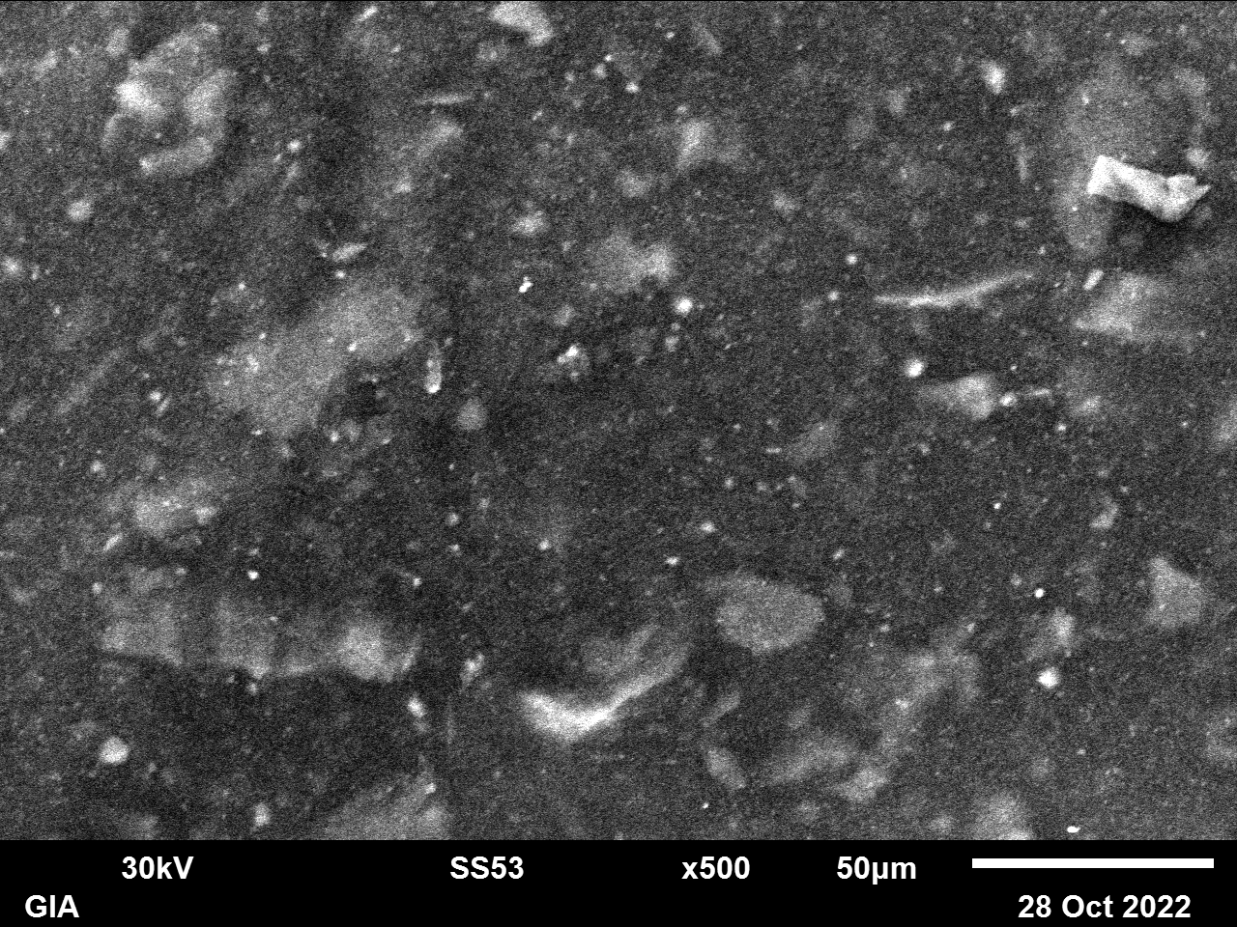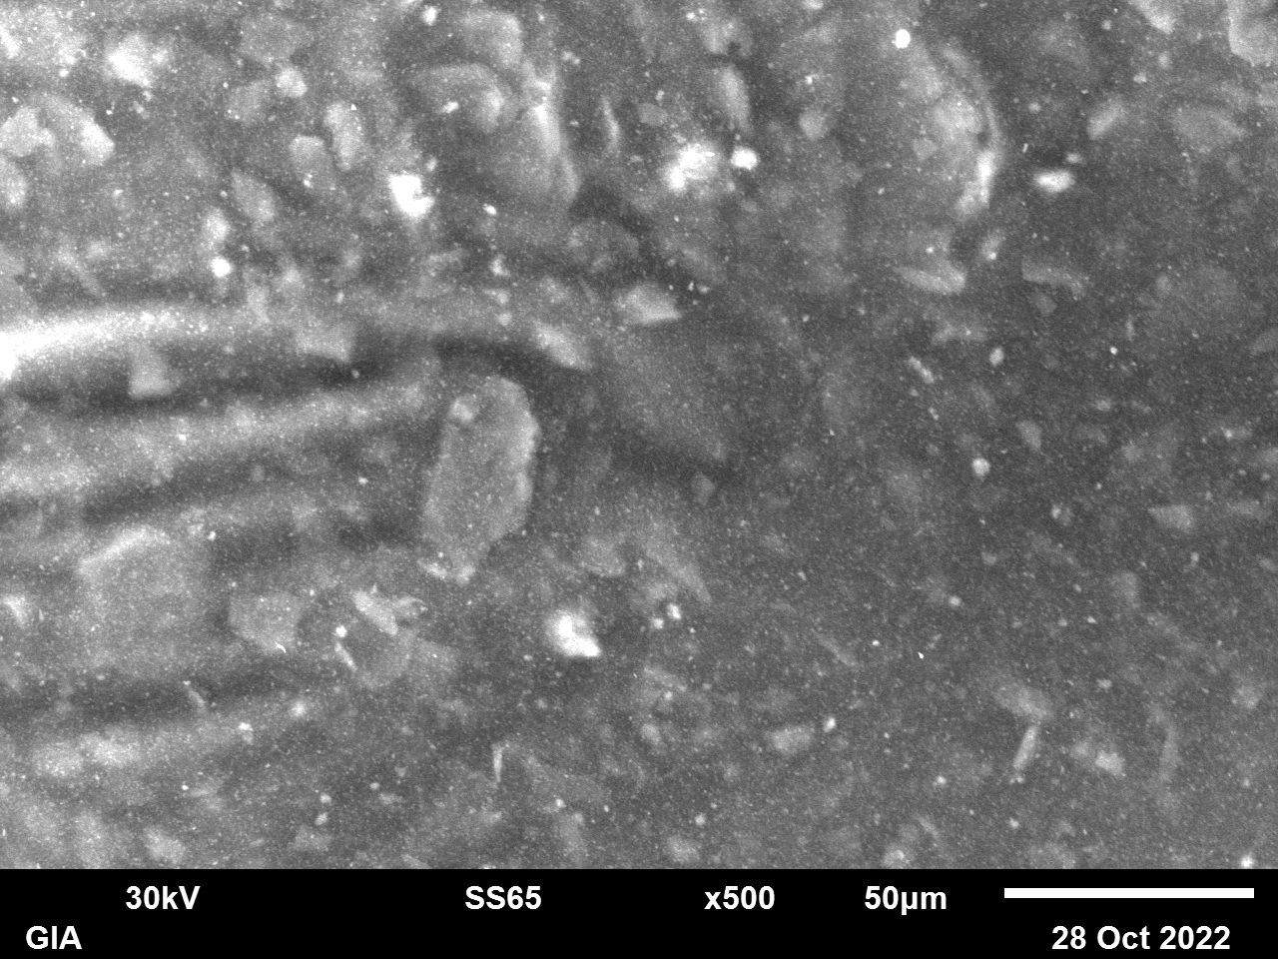
a) b)
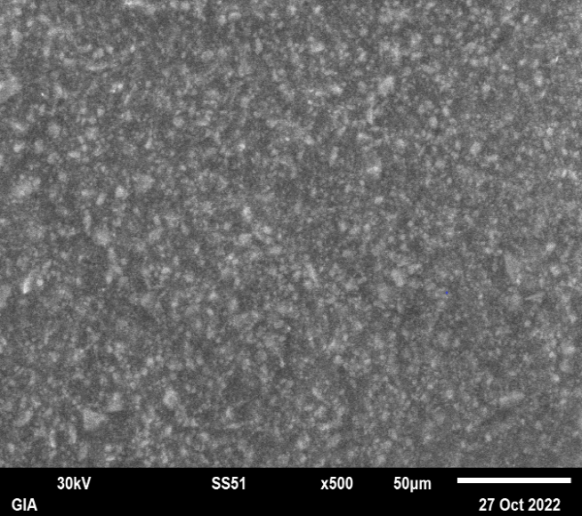
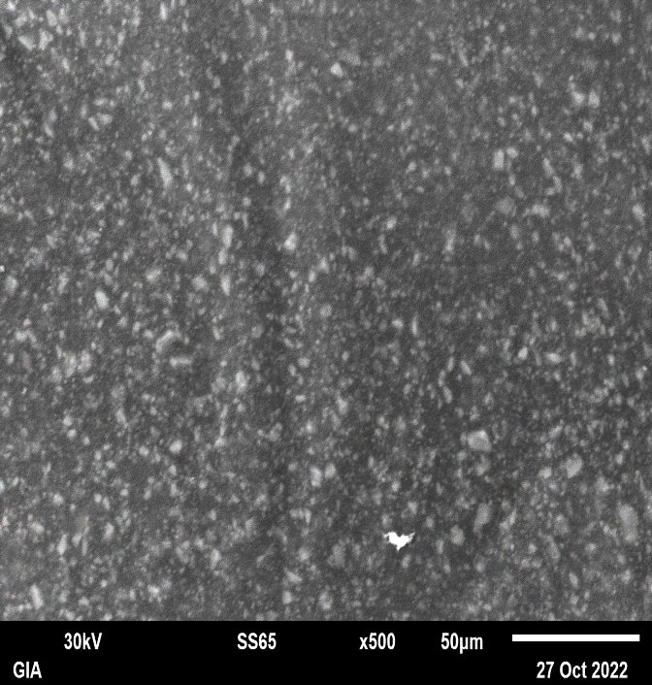

c) d)

Figure 1. SEM micrographs of coatings S1–S4:
(a) S1 – conventional PF-115;
(b) S2 – PF-115 + nanocalcite;
(c) S3 – PF-115 + nanocalcite + ZnO;
(d) S4 – PF-115 + nanocalcite + ZnO + Cu₂O
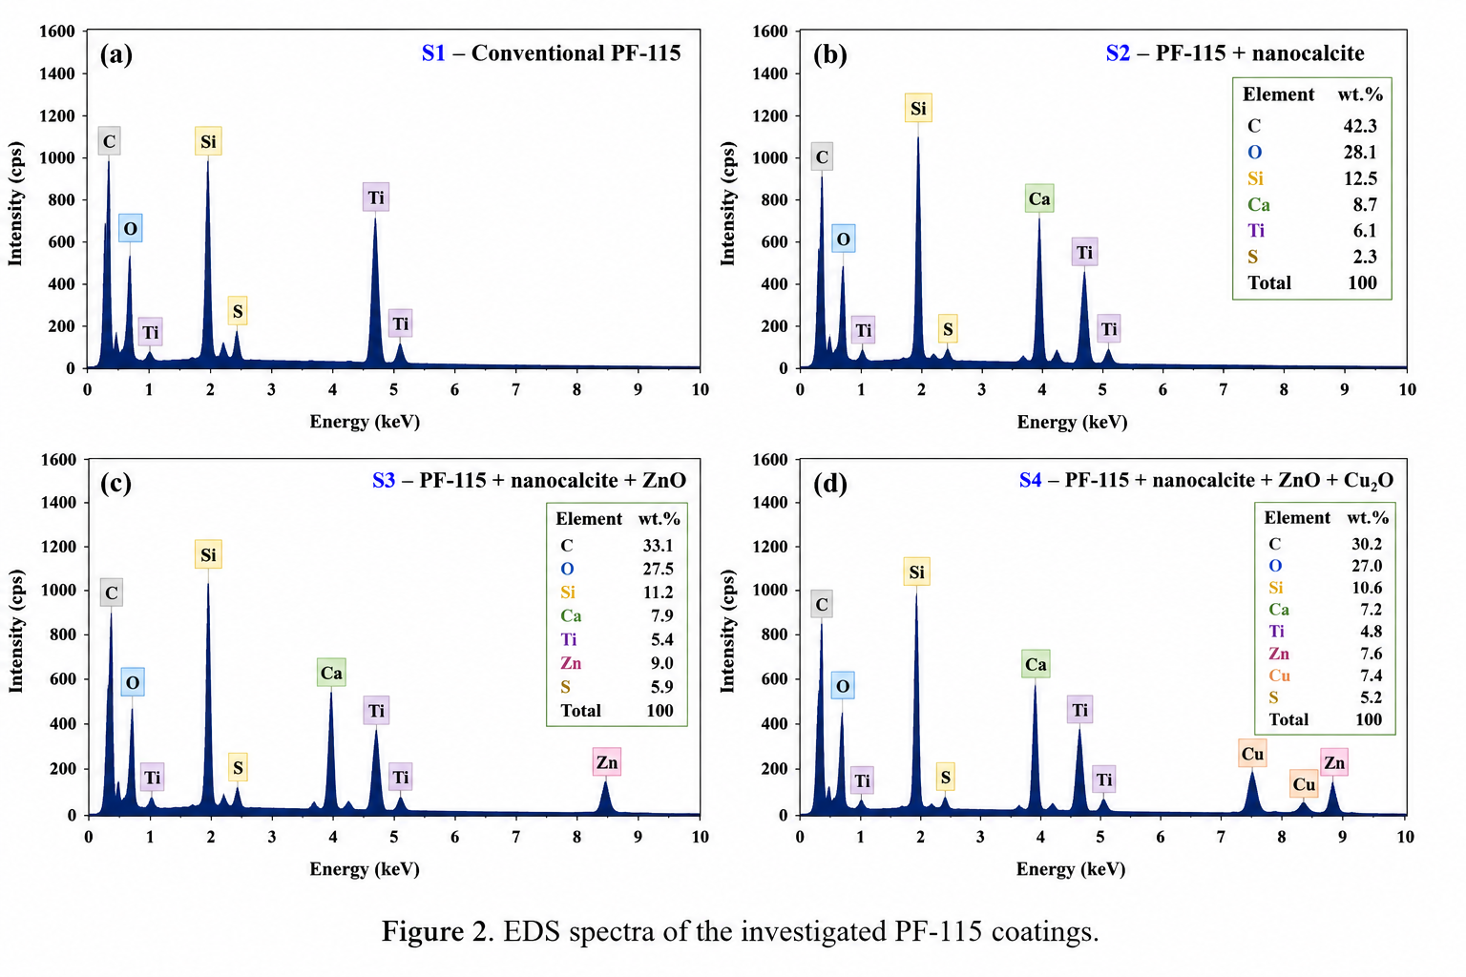
Figure 2. EDS spectra of the investigated PF-115 coatings

3.2. Electrochemical Corrosion Behaviour
The electrochemical corrosion behaviour of the coatings was evaluated using electrochemical impedance spectroscopy (EIS) and potentiodynamic polarization measurements. The EIS results provided information on the barrier properties and electrochemical resistance of the coating systems, while polarization measurements were used to determine the corrosion potential and corrosion current density.
The Nyquist plots showed a progressive increase in the diameter of the capacitive semicircles from S1 to S4. This behaviour indicates an increase in the resistance to electrochemical charge transfer and therefore an improvement in the protective properties of the coating. The largest impedance response was observed for S4, demonstrating the superior barrier performance of the coating containing the combined nanomodifiers.

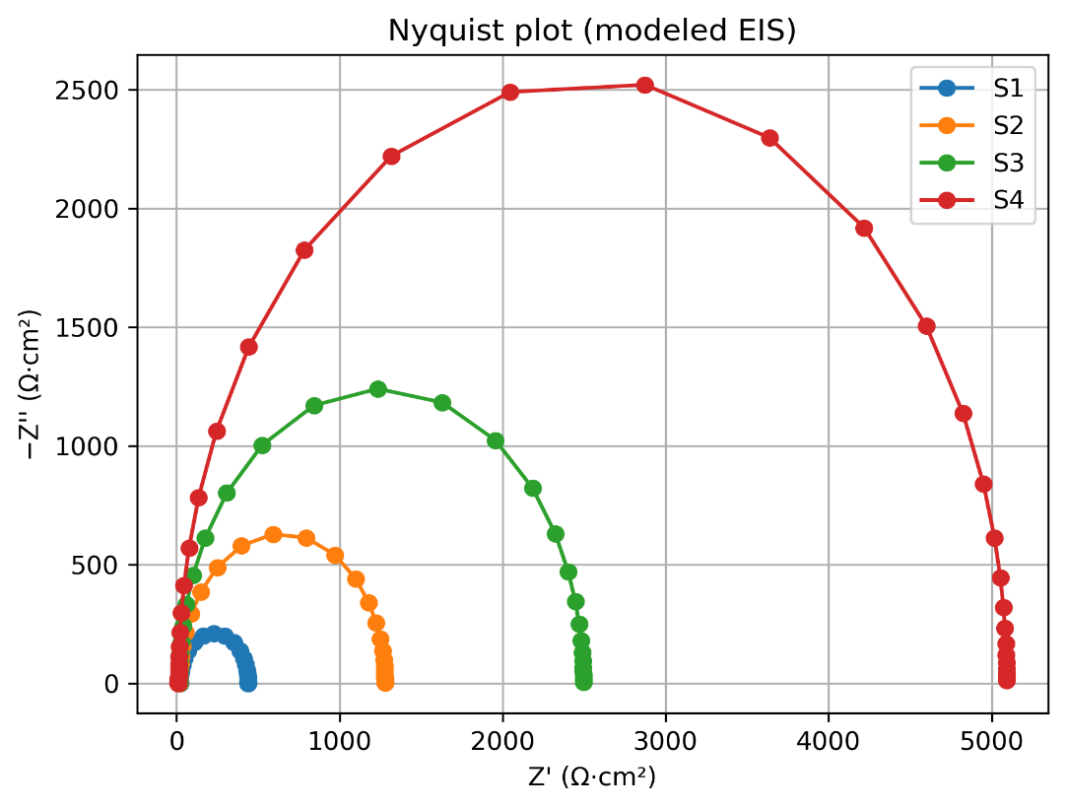
Figure 3. Nyquist plots of the investigated PF-115 coating systems

The Bode plots further confirmed the improvement in coating performance. The nanomodified systems exhibited higher impedance values, particularly in the low-frequency region, compared with the conventional PF-115 coating. The increase in low-frequency impedance is indicative of improved resistance to electrolyte penetration and enhanced barrier properties of the protective layer.

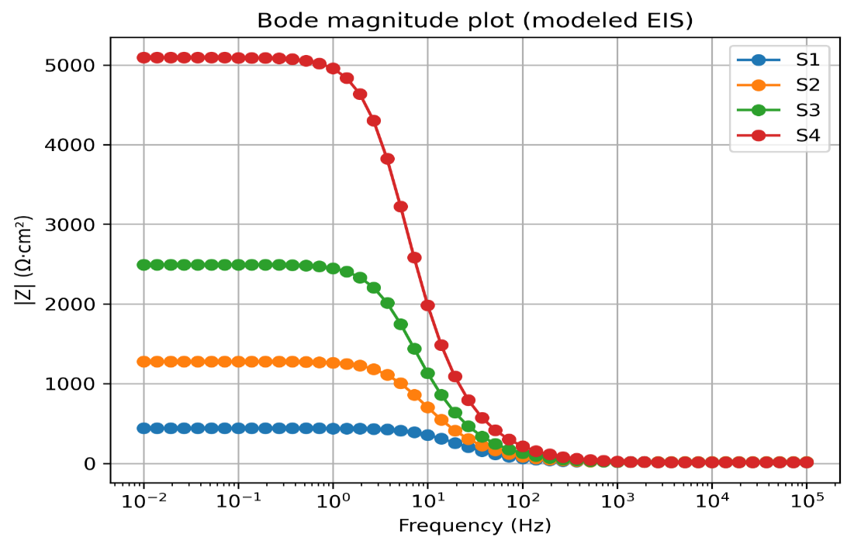

Figure 4. Bode plots of the investigated PF-115 coating systems

The quantitative electrochemical parameters are summarized in Table 2. A clear progressive improvement was observed from S1 to S4. The charge-transfer resistance (R_{ct}) increased from 420 Ω·cm² for S1 to 1260 Ω·cm² for S2, 2480 Ω·cm² for S3, and 5080 Ω·cm² for S4.
Thus, the fully nanomodified S4 coating exhibited an approximately 12.1-fold increase in R_{ct} compared with the conventional PF-115 coating. This substantial increase indicates a considerably stronger resistance to electrochemical processes occurring at the coating–steel interface.
At the same time, the corrosion current density (i_{corr}) decreased progressively from 3.26 μA cm⁻² for S1 to 1.64 μA cm⁻² for S2, 0.74 μA cm⁻² for S3, and 0.31 μA cm⁻² for S4. Consequently, the final nanomodified system demonstrated an approximately 90.5% reduction in corrosion current density relative to the unmodified PF-115 coating.
The corrosion potential (E_{corr}) also shifted toward more positive values, from –0.521 V for S1 to –0.487 V for S2, –0.462 V for S3, and –0.445 V for S4. The simultaneous increase in R_{ct}, decrease in i_{corr}, and positive shift in E_{corr} provide consistent evidence of the progressive improvement in corrosion protection.

Table 2

Electrochemical parameters of the investigated PF-115 coatings
Sample | Coating composition | E_{corr} (V) | i_{corr} (μA cm⁻²) | R_{ct} (Ω·cm²)
S1 | Conventional PF-115 | –0.521 | 3.26 | 420
S2 | PF-115 + Nanocalcite | –0.487 | 1.64 | 1260
S3 | PF-115 + Nanocalcite + ZnO | –0.462 | 0.74 | 2480
S4 | PF-115 + Nanocalcite + ZnO + Cu₂O | –0.445 | 0.31 | 5080

The progressive changes between S1 and S4 also provide insight into the contribution of the individual nanomodifiers. The incorporation of nanocalcite increased R_{ct} from 420 to 1260 Ω·cm², corresponding to an approximately threefold increase compared with the reference coating. The subsequent addition of ZnO further increased R_{ct} to 2480 Ω·cm², indicating an additional improvement in barrier performance. The final incorporation of Cu₂O resulted in the highest R_{ct} value of 5080 Ω·cm² and the lowest i_{corr} value of 0.31 μA cm⁻².
These electrochemical results are consistent with the SEM observations. The progressively more compact coating structure increases the resistance to transport of aggressive species toward the steel substrate. Consequently, the electrochemical reactions at the coating–steel interface are restricted, resulting in higher charge-transfer resistance and lower corrosion current density.

3.3. Proposed Corrosion Protection Mechanism
Based on the combined SEM, EDS, EIS, and potentiodynamic polarization results, a proposed corrosion protection mechanism for the nanomodified PF-115 coating is presented in Figure 5.
Nanocalcite acts primarily as a nanostructured filler, contributing to the densification of the polymer matrix and reducing the number of pathways available for the penetration of aggressive species. The incorporation of ZnO further improves the barrier characteristics of the coating, increasing resistance to the transport of water, oxygen, and chloride ions. Cu₂O provides an additional active corrosion-protective contribution at the coating–steel interface.
The combined incorporation of nanocalcite, ZnO, and Cu₂O therefore produces a synergistic protective effect. The progressively denser coating restricts the penetration of aggressive species toward the steel surface and suppresses electrochemical corrosion reactions. This behaviour is reflected quantitatively by the approximately 12.1-fold increase in R_{ct} and 90.5% reduction in i_{corr} observed for S4 compared with S1.
The proposed mechanism is therefore based on three complementary effects: matrix densification by nanocalcite, enhanced barrier protection by ZnO, and additional active corrosion protection provided by Cu₂O. Their combined action results in a more resistant coating–steel interface and substantially improves the overall corrosion protection performance of the PF-115 coating.
Figure 5 presents the proposed corrosion protection mechanism of the investigated PF-115 coatings and illustrates the progressive improvement in protective performance from S1 to S4.
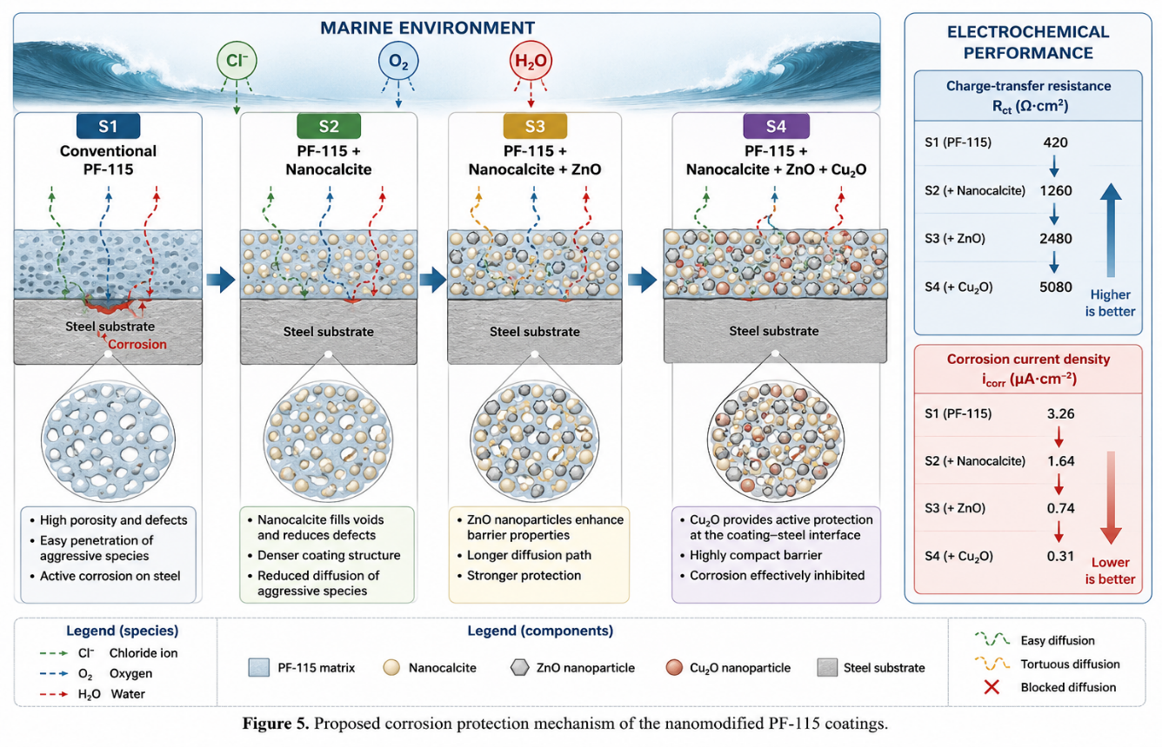
Figure 5. Proposed corrosion protection mechanism of PF-115 coatings from S1 to S4

4. Conclusions
The present study demonstrated that progressive nanomodification of PF-115 alkyd coatings with nanocalcite, ZnO, and Cu₂O significantly improves the corrosion protection performance of marine steel.
The incorporation of the nanomodifiers resulted in a progressively more compact and homogeneous coating structure, as indicated by SEM observations and supported by EDS analysis. The electrochemical results confirmed a corresponding improvement in the barrier and protective properties of the coatings.
The fully nanomodified system (S4), containing nanocalcite, ZnO, and Cu₂O, exhibited the highest electrochemical resistance. Its charge-transfer resistance increased from 420 to 5080 Ω·cm², corresponding to an approximately 12.1-fold increase compared with the conventional PF-115 coating (S1). At the same time, the corrosion current density decreased from 3.26 to 0.31 μA cm⁻², representing an approximately 90.5% reduction in corrosion activity.
The progressive improvement from S1 to S4 indicates that the incorporated nanomodifiers provide complementary protective functions. Nanocalcite contributes to matrix densification, ZnO enhances the barrier properties of the coating, and Cu₂O provides an additional active corrosion-protective effect. Their combined action restricts the penetration of aggressive species and suppresses electrochemical reactions at the coating–steel interface.
Overall, the developed nanomodified PF-115 coating demonstrates considerable potential as a sustainable protective system for marine steel structures. The obtained results provide a basis for further optimization of nanomodified alkyd coatings for applications in shipbuilding, marine infrastructure, and offshore engineering.

5. References
- Olajire, A.A. Recent advances on organic coating system technologies for corrosion protection of offshore metallic structures. Journal of Molecular Liquids, 2018, 269, 572–606. https://doi.org/10.1016/j.molliq.2018.08.053.
- Deyab, M.A. Anticorrosion properties of nanocomposites coatings: A critical review. Journal of Molecular Liquids, 2020, 313, 113533. https://doi.org/10.1016/j.molliq.2020.113533
- Pei, W., Pei, X., Xie, Z., Wang, J. Research progress of marine anti-corrosion and wear-resistant coating. Tribology International, 2024, 198, 109864. https://doi.org/10.1016/j.triboint.2024.109864
- Dalmora, G.P.V., Borges Filho, E.P., Maraschin Conterato, A.A., Roso, W.S., Pereira, C.E., Dettmer, A. Methods of corrosion prevention for steel in marine environments: A review. Results in Surfaces and Interfaces, 2025, 18, 100430. https://doi.org/10.1016/j.rsurfi.2025.100430
- Firoozi, A.A., Firoozi, A.A., Oyejobi, D.O., Avudaiappan, S., Saavedra Flores, E. Enhanced durability and environmental sustainability in marine infrastructure: Innovations in anti-corrosive coating technologies. Results in Engineering, 2025, 26, 105144. https://doi.org/10.1016/j.rineng.2025.105144
- Pourhashem, S., Seif, A., Saba, F., Garmroudi Nezhad, E., Ji, X., Zhou, Z., Zhai, X., Mirzaee, M., Duan, J., Rashidi, A., Hou, B. Antifouling nanocomposite polymer coatings for marine applications: A review on experiments, mechanisms, and theoretical studies. Journal of Materials Science & Technology, 2022, 118, 73–113. https://doi.org/10.1016/j.jmst.2021.11.061
- Фатьянова, Н.В. Применение наполнителей на основе наномела и наноталька в судовых ЛКМ как один из способов повышения коррозионной стойкости корпуса судна // – Баку: SOCAR Proccedings, серия техн.науки, –2023, №2, – с.136-144. http://dx.doi.org/10.5510/OGP20230200856
- Fatyanova, N.V. , Mammadov, F.F. Environmental aspects of the use of marine coatings with nanocomponents. Processes of Petrochemistry and Oil Refining, Vol. 27, No. 2, 2026, pp. 476-485. https://doi.org/10.62972/1726-4685.2026.2.476

