Modelling Economic Variables in Offshore Oilwell Drilling
Dalmo S. Amorim Jr., Edmilson S. Moutinho, Hirdan K. M. Costa¹
¹IEE-USP - Institute of Energy and Environment, University of São Paulo, São Paulo, Brazil
*Corresponding author e-mail address: dalmo.amorim@usp.br

Keywords
Petroleum Engineering
Modeling
Drilling Cost
Environmental Preservation
Abstract
Drilling costs and CO₂ emissions in oilwell drilling are direct functions of the time spent on drilling operations, as the energy used during drilling operations is generated on-site by diesel-electric systems. The longer the operations take, the greater the diesel consumption, and the higher are costs and emissions. However, drilling time varies significantly from one well to another. These variations stem from differences in rock properties, drilling equipment, operational conditions, and drilling efficiency. Due to this complexity, traditional statistical methods are not sufficient to adequately analyze the operational results. In this study, we present regression models that can capture these complex relationships, providing a more accurate representation of the results in a field or sedimentary basin. The results offer new and valuable insights for technical, operational, economic, and contractual decision-making. An immediate application is supporting the assessment of testing new technologies and remunerating Turn-Key contracts. The conclusions of this work provide relevant and original contributions to the enterprise at the intersection of drilling engineering and environmental sustainability.

Contents
1. Introduction 117
2. Literature review 117
3. Methodology 118
4. Case Study 121
5. Conclusion 126

Introduction
Drilling operations are the most expensive part of the oil and gas exploration process (Rostamsowlat, Evans and Kwon 2022). To reduce their costs, an optimization process is required, beginning by understanding the boundary conditions and the dynamic phenomena involved in the oilfield’s drilling operations. The environment must be well understood to be modeled, so that the optimization processes become less intuitive and less influenced by marketing forces, and more based on lessons learned from analyzing statistical results.
However, the oilwell environment is so complex that building a model to predict the behavior of the drilling operations is almost impossible, once all-encompassing models embed very low coefficients of determination (R²) (Devore 2010). Additionally, most information about drilling operations cannot be verified directly, and it is necessary to infer drilling status based on indirect information provided by sensors, or to perform a full trip of the drill string to check, at the surface, the conditions of the bit or drill string elements. Examples: sharpening of cutters, dimensions of gage stabilizers, condition of bearings, etc. The cost of a round trip is so high that some elements are replaced as they reach the surface, minimizing the non-productive time spent in inspections to check for conditions.
This paper aims to disseminate the Amorim curve methodology, which is designed to optimize offshore oilwell drilling costs. A summary of its numerous outputs is provided to facilitate a desirable extension of a congress paper. The full description is available for open access, allowing researchers with validated drilling data to replicate charts, benchmarks, formulas, and tables using Microsoft Excel (S. Amorim Jr., 2025).

Literature review
Predicting involves making an estimation based on a model, along with an associated error. More precise predictions are made by the good models, where total errors are expected to be nearly zero (MathWorks 2024). As the environment of drilling operations involves numerous elements interacting simultaneously, the result is a complex and interdependent reality, making it almost impossible to produce a universal model that predicts the results of drilling operations. In the authors’ vision, the deterministic parameter for modeling oilwell drilling should be the vertical depth, as rock compaction, abrasiveness, friction of the drill string, drilling harmonics and temperature all increase with depth. The contour conditions explain the numerous research efforts on the subject in the literature.
Most are directed towards modelling rates of penetration (ROP) using uneven deterministic parameters or strict geological conditions (Payne and Abbassian 1996). Research efforts have progressively used more complex analyses, as the variations of Artificial Neural Network, to treat the database (Wiktorski, Kuznetcov e Sui 2017), (Oyedere and Gray 2020), (Guo, et al. 2021), (A. Jabbar, et al. 2022) (Shaygan and Jamshidi 2022), (Wan, et al. 2023), (Miah, et al. 2025), (Han, et al. 2025), (Meng, et al. 2025) and (Nabavi, et al. 2025). More recently, well depth has been introduced as a deterministic variable of the model, assuming that higher errors of the modeled predictions are expected (Mantegazini, et al. 2024), (Hallai, Dobbi and Kechiched 2024) and (Ma, et al. 2025).
The Amorim curve methodology adopts the well depth as the deterministic parameter modelling due to a practical reason: systematically converting the coordinates of all well trajectories of a researched oilfield into vertical depth requires information at a level not yet practiced by the industry. It means that every well should have X-Y-Z coordinates for every bit run found in the database for its whole trajectory.

Methodology
This section describes the basic concepts of the methodology, which statistically fits drilling data from oil fields as a function of depth out of the drilling bits. Benchmarks of the fits provide unique insights into naturally dispersed results, offering predictions with a more reliable predictability than those supplied by averages of selected data, typically chosen while disregarding existing sets of positive and negative results from a drilling campaign (S. Amorim Jr., Moutinho, et al. 2024). The methodology is useful for providing predictions for well programs, generating outputs that reflect the influence of key performance indexes (KPIs) systematically collected in all wells, including bit type, technology, hydraulics, rig type, bit diameter and well inclination, among others.
Cost of drilling operations
The cost per meter is a unique, non-linear, and non-stochastic event, whose value is influenced by the complex aspects involved in drilling a segment of rock using the available technologies and operational practices (Van Kampen 1992). Calculated by Equation 1, CM continuously decreases as the operation progresses, as shown in Figure 1. At some point, CM stabilizes and slowly begins to increase until a decision is made to pull the bit from the well. Ideally, bits should be pulled at the minimum CM of the bit run.
Figure 1 - Evolution of CM for any bit run
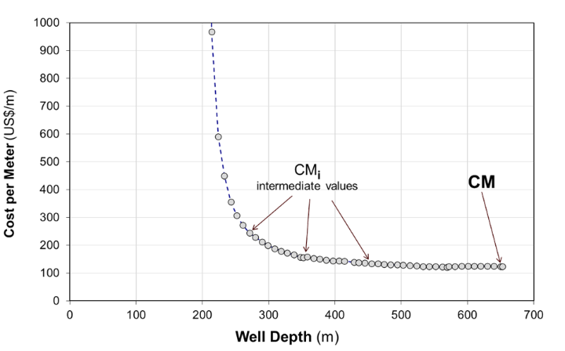
Source: (S. Amorim Jr. 2025)
The final value of CM for a bit run becomes tied, in the database, to MD, HR, and depth out.
Equation 1 - Cost per Meter
$CM=(CB+CH×(TT+HR))/MD$, where:
- CM - cost per meter of the section drilled MD ($/m)
- CB - cost of the drilling bit ($)
- CH - total cost of rig + special tools + infrastructure + logistics ($/h)
- TT - time to remove a bit from the well, change it and lower the string to resume drilling (h)
- HR - time spent to drill the section MD (h)
- MD - length drilled during the period of time HR (m)
The optimization process
The objective of the optimization process is to minimize drilling costs, directly proportional to the time spent, a variable dependent on the efficiency of the drilling operations. This reasoning applies integrally to the CO₂ emissions of the rig, which is indispensable to the enterprise as all the electric energy used must be generated using diesel at the rig location (S. Amorim Jr., Santos, et al., 2025). To drill each section entirely with one bit, to avoid intermediate trips, bits must last the expected lifespan necessary to drill their extension, expressed by Equation 2:
Equation 2 - Optimization of the length drilled
$${Max}_{MP}=f\left({Max}_{HR}\right)$$
The next step in the optimization is to drill every section using the least total time, achieved by maximizing the rate of penetration, where ROP = MD/HR. The research question is which set of KPIs results in the minimum time, expressed by Equation 3, which translates into finding the most efficient technical conditions for each bit run.
Equation 3 - Optimization of the drilling time
$${Max}_{ROP}=f({Min}_{HR})$$
The following actions are adjusting the energy levels applied to maximize ROP and life span (S. Amorim Jr. et al, 2019), and mitigate drill string vibrations and friction using FEA (S. Amorim Jr. et al, 2012), as in Equation 4. That will presumedly lead to achieving the minimum CM values after each run.
Equation 4 - Maximum drilling performance
$${Max}_{performance}=f({Max}_{ROP}, {Min}_{HR})$$
In summary, the drilling optimization is finding the best set of decisions based on the findings of the research, which should result in drilling every section of the well in the minimum time, expressed by Equation 5:
Equation 5 - Objective of the optimization method
$${Min}_{CM, {CO}_{2}}=f{(Max}_{MP},{Min}_{HR})$$
The objective in Equation 5 is achieved when the CM value is minimized, as shown in Figure 1, which represents the ideal moment to pull the string, provided that the bit does not reach the end of the section (S. Amorim Jr. 2025). Therefore, the objective of the research is to identify the set of conditions, as defined in Equation 5, focused on determining the lowest CM values within each depth range.
Benchmarking drilling data
The Amorim curve methodology employs an exponential regression of CM values versus well depth, resulting in a trend line. It represents the benchmark of all CM values achieved by the exploration campaign, making it possible to predict CM values in future wells under the set of KPIs used in Equation 6.

Equation 6 - Exponential benchmark of CM
${CM}_{i}=k1×e^{k2 × D}$, where:
- CM_{i} = value of the benchmark of CM at depth D, ($/m)
- D = measured depth of the trajectory, (m)
- k1 = value of the theoretical point where the trend curve meets the y-axis, ($/m)
- k2 = variable that reflects the variation of y values with the increase of D
Determining the sets of KPIs that result in Minimum (CM, CO₂) is very complex, as there are no standards for the design of trajectories, selection of drill string components or bits, energy levels, mud type etc. Geological conditions change with every meter drilled, adding friction between the string and the wellbore, and providing continuous changes in drilling harmonics with every new pipe added. It occurs simultaneously with a decrease in efficiency, caused by the wear of bit cutters, resulting in an increased overall energy demand from the rig. As so, within any depth range in the oilfield, a myriad of uneven results is produced, presenting very statistical variability.
CM benchmark trends are naturally expected to increase, as shown in Figure 2. As oilfields are explored, the typical initial CM values decrease provided by optimized bit runs and higher ROPs. Progress can be observed in the benchmark trends, which slowly become less inclined and decrease, indicated by reductions in k2.
Figure 2 - Benchmark of CM for a dataset of 5296-bit runs
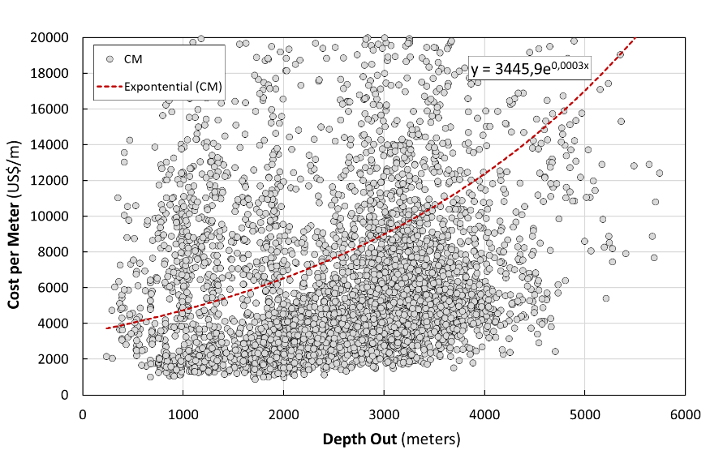
Gains provided by optimization
The methodology allows for research KPIs which have resulted in CM values sitting at the lowest part of the chart. It is done by filtering the database to isolate the KPI, like when researching the performances of 12.¼" bits. A new benchmark validates the findings, which can be replicated or improved in future wells in the area.
Positive results represent financial savings, calculated by using Equation 7, resulting from reduced rig time costs and savings achieved through efficient performance, compared to the surrounding wells in the same oilfield. The savings are the gap between CM_{i} and the predicted CM_{benchmark} (ΔCM), multiplied by the length drilled. The reasoning applies to losses when CM_{i} > CM_{benchmark}, as less efficient drilling results in more time to drill a determined segment.
Equation 7 - Financial savings gap between values predicted and achieved
$${Fin}_{sav}=MP×CM=MP×\left\{{CM}_{benchmark}-{CM}_{i}\right\}$$
- CM_{benchmark} - cost per meter predicted by the benchmark, ($/m)
The time saved by the optimization process (TS) is a direct calculation in Equation 8:
Equation 8 - Time saved by more efficient drilling
$$TS={Fin}_{sav}÷CH$$
- TS = lapse of rig time saved, (day)
The cost of drilling any segment of the trajectory between D1 and D2 is estimated by integrating Equation 6, which results in Equation 9. The estimation uses factors k1 and k2 extracted from benchmark formulas.
Equation 9 - Cost to drill any interval of the trajectory
$$CS=\int_{D1}^{D2}{CM} dD=\int_{D1}^{D2}{k_{1}×e^{k_{2}×D}} dD$$
$${CS=k}_{1}×\left\{\left(e^{k_{2}×D_{2}}\right)-\left(e^{k_{2}×D_{1}}\right)\right\}÷k_{2}$$
- CS = cost of drilling a segment D1 to D2, ($)
The reasoning also applies to the reduction in CO₂ mass achieved through more efficient operations. Similar to the drilling costs, it is directly proportional to the time drilling, with saved mass estimated by Equation 10:
Equation 10 - CO₂ mass reduced by more efficient drilling
$$M_{CO2}=TS×{Rig}_{CO2}$$
- RigCO₂ - daily emissions of CO₂/day of the rig, (ton/day)

Case Study
The sedimentary basins along the eastern coast of Brazil were formed during the rifting of the Gondwana Supercontinent, which led to the formation of the South Atlantic Ocean, and the separation of the African and American continents. The evaporites of the pre-salt sequence are the result of sedimentation in shallow waters and a semi-arid climate, shown in Figure 3, which created an extensive package of salts deposited in a lagoon environment under relatively stable tectonic conditions, likely connected to southern oceanic waters (Ávila e Luparelli 2015).
The petroleum habitat of the Campos Basin lies within the Lagoa Feia-Carapebus system, sourced from saline lacustrine shales that charge turbidite reservoirs, such as the Carapebus Formation. It led to thermal history and biodegradation, essential for the prolific, rift-related petroleum system linked to the Gondwana breakup. The main reservoir is composed of the turbidite sandstones of the Carapebus Formation. The petroleum system focuses on the interconnected source (shale) and reservoir systems (turbidite), characterized by effective generation and migration (BPS 2025).
Figure 3 - Geological section of the Espirito Santo Basin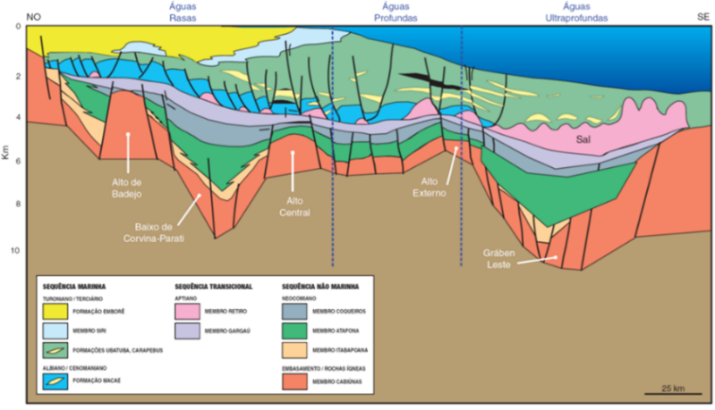
Source: (Castro e Picolini 2014)
Since the first well was spudded in 1971, the offshore part of the basin has been explored from waters as shallow as 12 m, down to the country's record of 3022 m, set in ultra-deep waters. A total of 3584 wells were drilled in the basin as of December 2025 (ANP 2025); Petrobras drilled a single onshore dry well in 1959. This case study utilizes a robust dataset from 1098 wells of seven oilfields, representing a total of 3584 wells drilled in the basin (ANP 2025). The analysis used a total of 5296 validated bit runs. Disregarding minor inaccuracies in the lines that define the regional structures in Figure 4, most wells of the seven fields were drilled within a distance of 50 km at an average water depth of approximately 1000 m.
Figure 4 - Main structures of the Campos basin
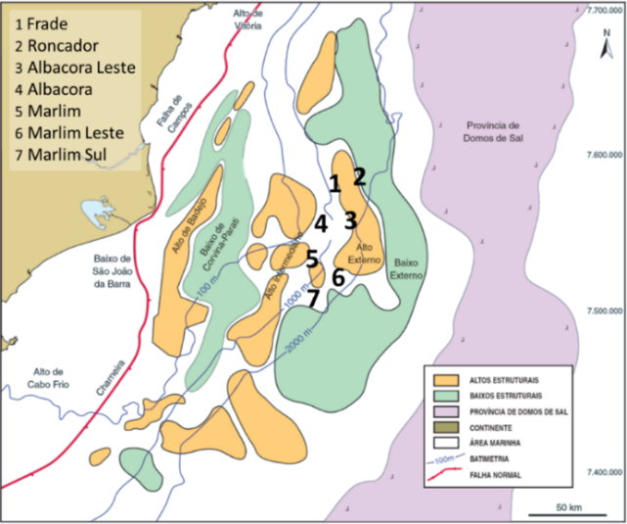
Source: (adapted by the author from CASTRO e PICOLINI, 2014)
Drilling performances
The case study begins by plotting performance versus depth for the main elements of Equation 1: the length drilled (MD) and the time drilling per bit run (HR), as shown in Figure 5. The charts indicate a high vertical distribution in all depth ranges, a common finding in any oilfield where this methodology is applied.
Figure 5 - Case study of MD and HR for the seven fields
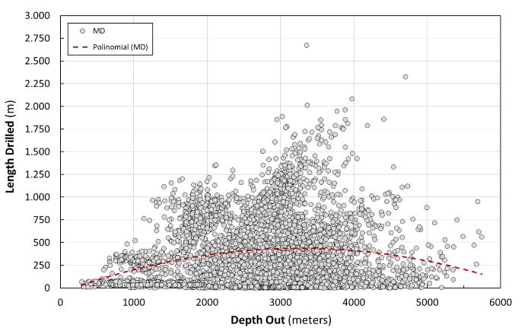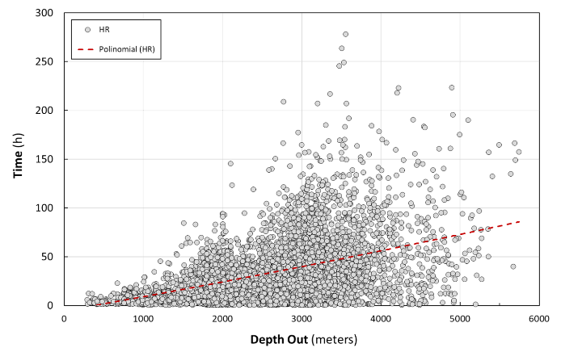
The remarkable vertical dispersion of results across any depth range renders the development of universal models an arduous task, posing a challenge in producing reliable predictions. Modelling such an environment is challenging and does not yield simple answers. The statistical fits use polynomials for MD and HR. The benchmarks in Figure 5 were expected to reflect a natural decline in performance as wells become deeper, rocks become harder, more abrasive, and bits wear out faster. However, this is not found in either charts. One reason is the length of the different sections, which progressively reduced to isolate different formations, being set intermediate casing. Performances can be filtered by bit diameter, providing specific additional charts.
A logarithmic fit is used for ROP, seen in Figure 6. A first conclusion is that the chart does not provide insights or present logical connections with the previous charts. However, it shows what is naturally expected: ROP declining with the well depth. Analyses can also be filtered by bit diameter, providing specific estimations for each diameter.
Figure 6 - Case study of ROP for the seven fields
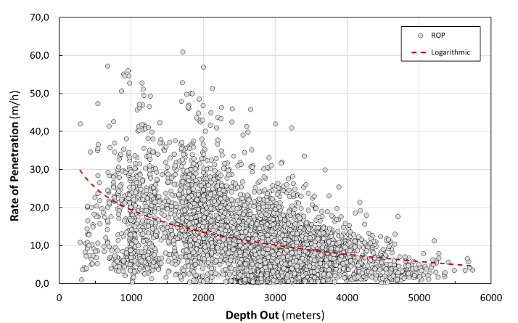
However, the findings necessary to solve Equation 5 are not yet available at this stage of the research. To optimize drilling costs, it is essential to determine the contour conditions of the lowest values of CM among the reported data, revisiting this step to refine the findings, as described below.
The Area Fingerprint
The set of decisions taken during the planning and exploration of an oilfield is reflected in each of the CM results found in a database. As such, plotting all CM values versus depth produces a unique chart: the area fingerprint, a starting point for searching for optimum conditions for each section. The area fingerprint for the seven fields is seen in Figure 7. There is a lack of results at the bottom left, due to the water depth.
Figure 7 - Fingerprint of the seven fields of the case study
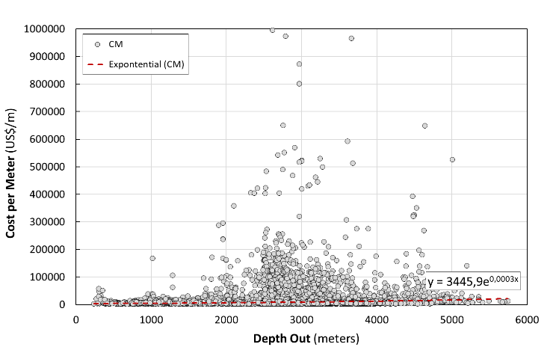
The vertical dispersion of CM results is also remarkable. A high concentration of high costs per meter in the mid-sections, at approximately 2500-3000 m, requires using the first data filter: CM versus bit technology. The finding is that coring operations are the origin of most of the high costs per meter, verified in the red dots plotted in Figure 8.
Figure 8 - Benchmark of CM for drilling technology
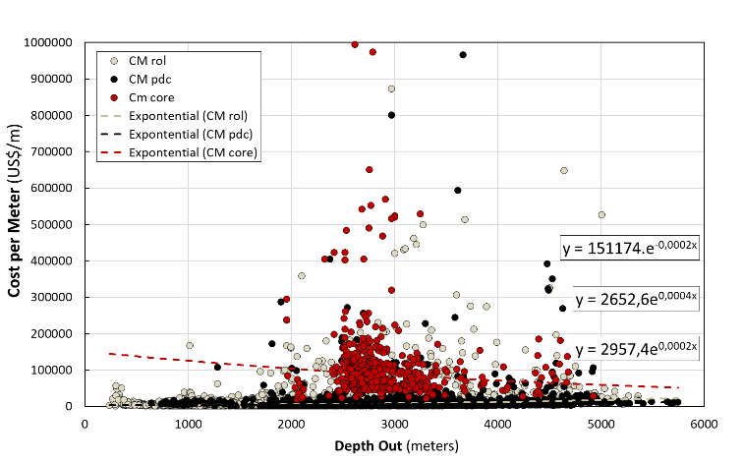
Zooming down the Y-axis to $60000/m produces Figure 9, providing a clearer vision of the benchmark formulas for the drilling technologies. Drilling with PDC bits is expected to cost approximately 50% of the cost with rollercone bits at this stage of the exploration (1984 to 2019), due to a 1:2 ration between the two k2 factors.
Figure 9 - Benchmarks for CM and drilling technology
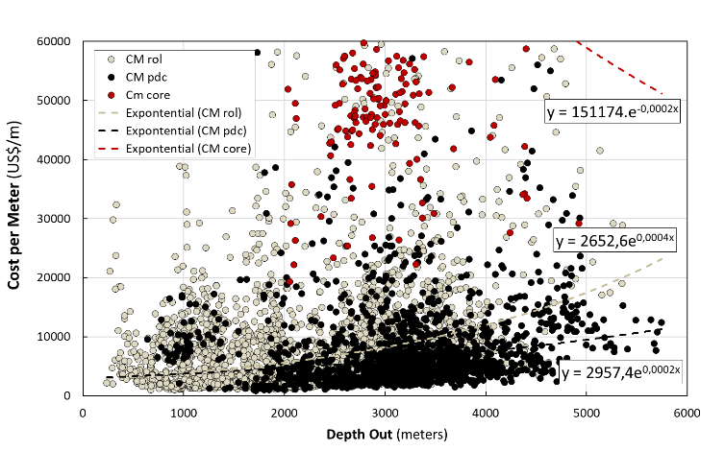
Next step: filter out the 496 coring operations and zoom in to $20000/m, as shown in Figure 10. The findings are that rollercone bits are predominant in shallow sections. PDC bits are more economical in mid- and deeper sections, providing a benchmark that sits below the rollercone bit benchmark.
Figure 10 - Benchmarks for CM, PDC and rollercone bits
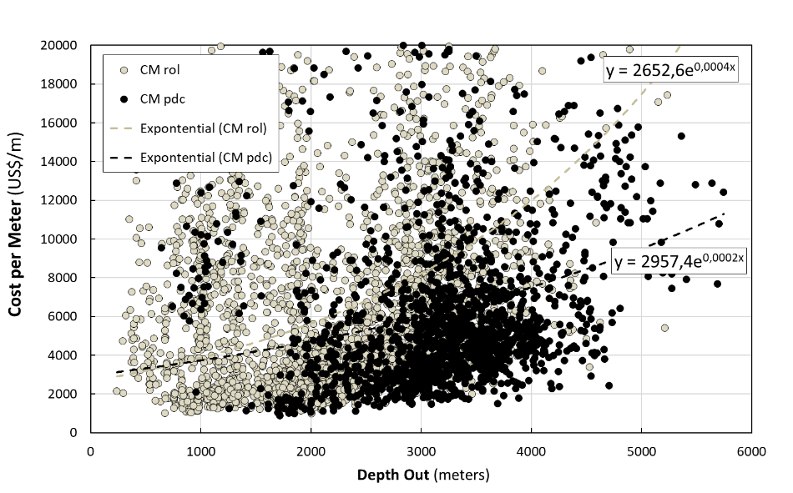
Next filters: hide the rollercone bits, filter bit diameter of the PDC bits. Figure 11 presents a densely populated chart, with 28” bits in black (3 runs), 17.½” in green, 12. ¼” in brown and 8.½” in light blue; benchmarks were not included to avoid image congestion. Analyses be further refined by filtering PDC cutter size, number of blades etc.
Figure 11 - Area fingerprint of CM for PDC bits and diameter
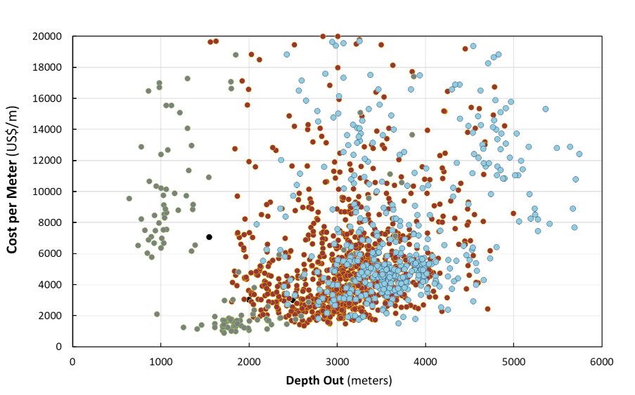
Further analyses can filter bit manufacturer, HSI (hydraulic horsepower per square inch), well inclination range, mud type, and usage of downhole motors or rotary steerable systems in directional wells, among other factors. Analyses might investigate rollercone bits by establishing filters for rollercone IADCs (McGehee, D.Y. et al. 1992), for extra protection at the gage, stabilizers or roller reamers in the BHA, total RPM when using motors, and others. Filtering KPIs and modeling results provide more consistent predictions than those obtained by averaging selected data. The process is completed by reverse engineering, which involves identifying the depth out of the best runs and examining the contour conditions in the database. Each set of filtered KPIs provides different formulas, so the most relevant analyses can be tracked over time, with k1 and k2 recorded in a table for the researched KPI.

Results
The cost of drilling a segment of the trajectory from depths D1 to D2, calculated using Equation 9, is represented at the bottom right of Figure 12. The concept can be applied to predict the cost of a whole well. In this case, the factors k1 and k2 used for the calculations are extracted from the benchmark equation for the filtered KPIs.
Figure 12 - Financial gaps
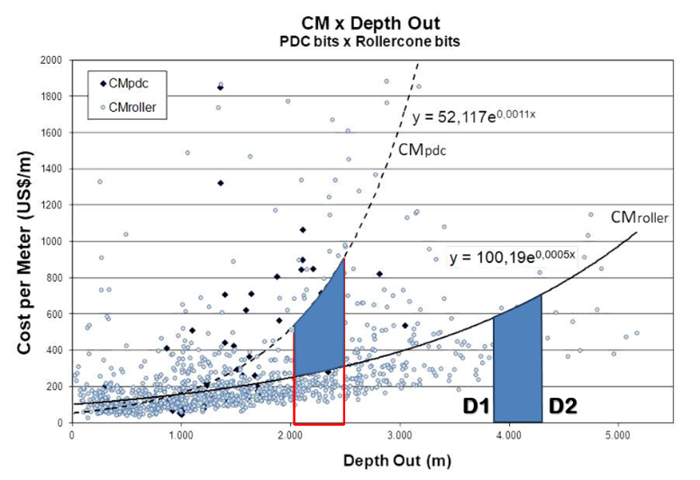
During any period of exploration of an oilfield, as new bits are run, the area fingerprint becomes more populated, and the benchmarks slowly change. The trend of increasing or decreasing k2 factors demonstrates improvements or setbacks resulting from the decisions made. The trends of increasing or decreasing k2 factors demonstrate the improvements or setbacks resulting from the optimization processes and decisions made.
In this sense, it is possible to document the evolution of technologies as a function of time, comparing the factor k2 of analyses made in different years of exploration. By considering time as a KPI, the financial impact between two periods of exploration phases can be provided, similar to the area represented by the other blue area in Figure 12, which is achieved by comparing benchmarks and calculating the resulting financial impact.

Conclusion
The article demonstrated applications using the Amorim curve methodology, which can be replicated by any researcher with verified data using Excel. The status of optimization processes can be evaluated in economic terms, revealing notable achievements by filtering different KPIs. The savings resulting from using available technologies are determined by comparing the overall oilfield benchmark with those resulting from a predefined KPI. Details and additional applications of the methodology are provided at the dissertation of the author.
A case study demonstrated the typical high variability of oilfield exploration performances, which makes modeling such environments into a very complex mission. By using the cost per meter as the primary source of analysis, rather than drilling performance, a KPI systematically collected for all wells in the oilfield can narrow down the findings, detecting the most efficient combination of factors for each well segment.
With the subject of carbon credits undergoing legal regulations worldwide, the methodology also serves as a starting point for measuring environmental savings in more efficient drilling operations. The methodology introduces new metrics, serving as benchmarks for operators to claim carbon credits when developing more efficient technologies. The action benefits society by reducing the enterprise’s cost and its environmental impact.
References

A. Jabbar, Ahmad, Ahmed A. Mahmoud, Salaheldin Elkatatny, and Mahmoud Abughaban. "Artificial neural networks-based correlation for evaluating the rate of penetration in a vertical carbonate formation for an entire oil field." Journal of Petroleum Science and Engineering, 2022.
Amorim Jr., Dalmo S., H. K. M. Costa, and Edmilson M. Santos. "Reducing Costs and CO2 Emissions in Oilwell Drilling: Methodology and Case Study." BRAZILIAN JOURNAL OF PETROLEUM AND GAS, 2025: 23-31.
Amorim Jr., Dalmo S., Pablo L. Silva, Hirdan K. M. Costa, and Edmilson M. Santos. "Benchmarking Offshore Drilling: Methodology and Case Study." REM International, 2025: 12.
ANP. Data. 2025. https://www.gov.br/anp/pt-br/assuntos/exploracao-e-producao-de-oleo-e-gas/dados-tecnicos/ad/tabela-de-pocos.xlsx.
Ávila, Ronan, and Ariely Luparelli. "Bacia do Espírito Santo." Brasil 13a Rodada, ANP, 2015, 96.
BPS. The Petroleum Habitat of the Campos Basin based on detailed Geological, Geochemical and 2D Petroleum System Modeling. 2025. https://brazilpetrostudies.com.br/multiclient/campos/the-petroleum-habitat-of-the-campos-basin-based-on-detailed-geological-geochemical-and-2d-petroleum-system-modeling/.
Castro, Ricardo D., e J. P. Picolini. “Principais aspectos da geologia regional da Bacia de Campos.” Geologia e Geomorfologia, 2014: 12.
Devore, Jay L. Probability & Statistics for Engineering and the Sciences. Eigth edition. San Luis Obispo, CA: CENGAGE Learning, 2010.
Guo, Ying, Guangying Ren, Yang Fei, Yong Yang, Dmitry O. Bokov, and Irina N. Fardeeva. "An analytical method to select appropriate linear and non-linear correlations on the effectiveness of penetration rate parameter towards mechanical specific energy." Energy Reports, 2021: 3647-3654.
Hallai, Said, Abdelmadjid Dobbi, and Rabah Kechiched. "Modeling rate of penetration using hybridization of Artificial Neural Network and Artificial Fish Swarm algorithm." Petroleum Science and Technology, 2024: 19.
Han, Xue Yin, Zhen Xin Zhang, Peng Fei Cheng, Xue Sen Qian, Yu Ming Liu, and Bo Tao Lin. "Application and analysis of the shapley additive explanations in predicting the rate of penetration." Petroleum Science and Technology, 11 2025: 20.
Ma, Zheng Chao, et al. "Intelligent prediction of rate of penetration through meta-learning and data augmentation synergy under limited sample." Geoenergy Science and Engineering, 2025.
Mantegazini, Diunay Zuliani, Andreas Nascimento, Mauro Hugo Mathias, Oldrich J. R. Guzman, and Matthias Reich. "Optimization of Rate of Penetration and Mechanical Specific Energy Using Response Surface Methodology and Multi-Objective Optimization." Applied Sciences, 2024.
MathWorks. Parametric Fitting. 2024. https://www.mathworks.com/help/curvefit/parametric-fitting.html.
McGehee, D.Y. et al. "The IADC Roller Bit Classification System." IADC/SPE 23937. Louisiana, USA: Society of Petroleum Engineers, 1992. 801 - 818.
Meng, Han, Zhen Xin Zhang, Xue Yin Han, and Bo Tao Lin. "Research on rate of penetration prediction method integrating bit wear and pretraining mechanism." Petroleum Science Bulletin, 2025.
Miah, Mohammad I., Mohammad T. Reza, Mizanur Rahman, and Maruf Alam. "Extended Genetic Algorithm-Based Improved Model for Drilling Rate of Penetration Using Mud Logging Data." 8th International Conference on Engineering Research, Innovation and Education. 2025. 9.
Nabavi, Zahra, et al. "Prediction of Rotary Drilling Rate of Penetration in Surface Mines Using Machine Learning Techniques." Rock Mechanics and Rock Engineering, 2025.
Oyedere, Mayowa, and Ken Gray. "ROP and TOB optimization using machine learning classification algorithms." Journal of Natural Gas Science and Engineering, 02 25, 2020: 13.
Payne, M. L., and F. Abbassian. "Advanced Torque and Drag Considerations in Extended-Reach Wells." IADC/SPE Drilling Conference. New Orleans, 1996.
Rostamsowlat, Iman, Brian Evans, and Hyock J. Kwon. "A review of the frictional contact in rock cutting with a PDC bit." Journal of Petroleum Science and Engineering, 2022: 17.
S. Amorim Jr., Dalmo. "Modelling Economic and Environmental Variables in Offshore Oilwell Drilling." 2025. 321.
S. Amorim Jr., Dalmo, Chris Hanley, and Daltro J. Leite. "Parameter Definition Using Vibration Prediction Software Leads to Significant Drilling Performance Improvements." Edited by SPE. Latin American and Caribbean Petroleum Engineering Conference. Ciudad de México, 2012.
S. Amorim Jr., Dalmo, Edmilson S. Moutinho, Otto L. A. Santos, José Umberto A. Borges, João H. Rittershaussen, and Milena A. R. Amorim. "CO2 Reduction in Oilwell Drilling: Methodology and Case Study." IGRC 2024. Banff, CA, 2024. 12.
S. Amorim Jr., Dalmo, Otto L.A. Santos, and Ricardo C. Azevedo. "New Industry Standards to Increase the Reliability of Drilling Operations." Holos (IFES), 2019.
Shaygan, Kaveh, and Saeid Jamshidi. "Prediction of rate of penetration in directional drilling using data mining techniques." Journal of Petroleum Science and Engineering, 11 2022.
Van Kampen, N. G. Stochastic Processes in Physics and Chemistry. Fourth Edition. Oxford, EN: Elsevier, 1992.
Wan, Youwei, Xiangjun Liu, Jian Xiong, and Lixi Liang. "Intelligent Prediction of Drilling Rate of Penetration Based on Method-Data Dual Validity Analysis." SPE Journal, 10 2023.
Wiktorski, Ekaterina, Artem Kuznetcov, and Dan Sui. "ROP Optimization and Modeling in Directional Drilling Process." Edited by Society of Petroleum Engineers. SPE Bergen One Day Seminar. Bergen, Norway, 2017. 14.

