**Morin Hydrate Provides A Protective and Therapeutic Option Against Diabetic Neuropathy Via Suppression of Oxidative Stress, Neuroinflammation and Neuronal Apoptosis**

***Serkan YILDIRIM1*2, , Emin ŞENGÜL3, Nariste KADIRALİEVA4, Sezim BELEK KIZI 1, Yavuz Selim SAĞLAM2, İsmail BOLAT2, Metin KİLİLİOĞLU2, Berrah GÖZEGİR2, Esra DERELİOĞLU2, Betül ORHAN2***

*1Department of Pathology, Faculty Vterinary Medicine, University of Manas, Bishkek, Krygiztan*

*2Department of Pathology, Faculty Vterinary Medicine, University of Ataturk, Erzurum, Turkiye*

*3Department of Physiology, Faculty Vterinary Medicine, University of Ataturk, Erzurum, Turkiye*

*4Department of Histology, Faculty Vterinary Medicine, University of Manas, Bishkek, Krygiztan*

Presenting author: Serkan YILDIRIM *e-mail address: erkan.yildirım@manas.edu.tr*

**Abstract**

Diabetes Mellitus (DM) is a metabolic disease that is very common worldwide. That is caused by insulin deficiency or inadequate effects of insulin on target tissues. DM has many complications such as nephropathy, retinopathy, peripheral neuropathy and cardiomyopathy due to hyperglycemia. The most common among these is neuropathy. Diabetic neuropathy is a loss of sensory function that begins in the distal lower extremities and is also characterized by pain. This situation negatively affects life satisfaction in many people and makes them dependent on drugs for a long time. Since DM is a chronic disease, herbal treatments have been used more widely in the treatment of the disease in recent years in order to have fewer side effects. Morin Hydrate is a bioflavonoid compound belonging to the Moraceae family. It is known to have antioxidant, anti-inflammatory, cardioprotective, neuroprotective, antidiabetic and antimicrobial potential. Therefore, it is aimed to investigate the protective and supportive effect of morin hydrate on nephrotoxicity due to DM. For this purpose, study groups were created: Control, Diabetes, Diabetes + Metformin, Diabetes + Metformin + MH 100 group, Diabetes + MN100 and MH100. Morin hydrated prevented lipid peroxidation, GSH depletion, and reduction of antioxidant enzyme activities, CAT, SOD and GPx. It was determined that it significantly reduced MDA level, ROS production, nNOS, and 8 OHdG expressions. It was determined that it significantly reduced the level of GFAP, an important marker of neuroinflammation caused by hyperglycemia, and the expression of NeUN and H2AX, markers of neuronal damage.

As a result, it has been revealed that morin hydrate prevents oxidative stress, neuroinflammation and neuronal apoptosis due to hyperglycemia, has a neuroprotective effect and can also provide supportive treatment together with the reference treatment.

Key words: Apoptosis, Diabetes mellitus, Neuropathy, Neuroinflammation, Morin hydrate.

1. **INTRODUCTION**

Diabetes mellitus (DM) is a life-threatening condition that negatively affects quality of life, impacts nearly all bodily systems, is prevalent worldwide, places a significant economic burden on countries, and causes neuropathy, nephropathy, retinopathy, and atherosclerosis. Chronic hyperglycemia can lead to disturbances in carbohydrate, fat, and protein metabolism, as well as serious health problems such as neuropathy, retinopathy, nephropathy, peripheral vascular disease, coronary artery disease, and atherosclerosis. Diabetic neuropathy is one of the most common chronic complications, affecting approximately 50% of patients with diabetes.

The concept of phytotherapy emerged in the early 1900s with the publication of the phytotherapy book "La Presse Médicale" by French physician Henri Leclerc. Phytotherapy encompasses the use of medications or active substances prepared from plants through various methods for the treatment and prevention of diseases, as well as preventing disease-related complications. The value of phytotherapy is increasingly being recognized, as evidenced by the establishment of alternative medicine or complementary medicine departments in medical schools, which have become very popular in recent years.

Today, many scientific studies are being conducted to identify the benefits of traditionally known medicinal plants in order to develop alternative medical treatments. Morin is a natural bioflavonoid obtained from onions, seaweed, Indian guava (*Psidium guajava*), almonds (*Prunus dulcis*), fig (*Chlorophora tinctoria*), red wine, Osage orange, and other members of the Moraceae family. It possesses various pharmacological properties such as antioxidant, anti-inflammatory, chemoprotective, and anticancer activities. Morin has been well-studied for its antioxidant and mitochondrial protective effects.

Therefore, in this study, we aim to determine the pathophysiology of diabetes mellitus-induced neurotoxicity, as well as the effect and possible mechanism of Morin hydrate against this neurotoxicity using histopathological, immunohistochemical, immunofluorescence, and biochemical methods.

1. **MATERIALS AND METHODS**

**Histopathological Examination**

**T**issue samples taken as a result of necropsy performed in animals were detected in 10% buffered formalin solution for 48 hours. Routine tissue follow-up procedures. 4 µm thick sections were taken from each block. The preparations prepared for histopathological examination were stained with hematoxylin-eosin (H&E) and examined with a light microscope (Olympus, Japan). Examined were evaluated as none (-), mild (+), moderate (++) and severe (+++) according to their pathological findings.

**Immunohistochemical Examination**

Tissue sections taken from an adhesive (poly-L-Lysin) slide for immunoperoxidase analysis were passed through xylol and alcohol series, and were deparaffinized and dehydrated. Routine tissue follow-up procedures After Primary antibody (GFAP, Dilution Ratio: 1/100, UK) was dropped on the sections. 3-3 ‘Diaminobenzidine (DAB) chromogen was dropped to the sections. Then the prepared sections examined with light microscope (ZEISS AXIO, Germany).

* 1. **Research Material**

The experimental animals used in this thesis study will be obtained from the Directorate of Medical Experimental Application and Research Center at Atatürk University. For this purpose, 60 adult female Sprague-Dawley rats weighing 220-250 g are planned to be used.

* 1. **Establishment of Experimental Groups**

The study groups will be established as follows: Control, Diabetes, Diabetes+Metformin, Diabetes+MH25, Diabetes+MH50, and MH50, with 10 rats of equal weight in each group. Rats in all experimental groups except the control group will be administered a single intraperitoneal dose (0.5 ml) of 50 mg/kg streptozotocin (STZ) (BioVision Cat No:1930-1000) solution dissolved in cold citrate buffer (0.1 M, pH 4.5). On the 8th day of administration, following a 12-hour fasting period, blood glucose levels will be measured from the tail veins of rats using a glucometer. Rats with fasting blood glucose levels higher than 250 mg/dL will be considered as having diabetes mellitus. The experimental group protocols have been determined as follows (Belhan et al., 2020). Diabetes will be induced in all rats except the control group

**Control group:** Rats in this group (n=10) will be injected with a single intraperitoneal (i.p.) dose of 50 mg/kg saline solution.

**Diabetes group:** Rats in this group will be administered a single intraperitoneal dose of 50 mg/kg STZ (16).

**Diabetes + Metformin group:** Rats in this group (n=10) will be administered a single i.p. dose of 50 mg/kg STZ. Additionally, Metformin (Glifor 1000mg) at a dose of 100 mg/kg will be given to the experimental animals daily at the same time via gastric gavage.

**Diabetes + Metformin + MH 100 group:** Rats in this group (n=10) will be administered a single i.p. dose of 50 mg/kg STZ. Additionally, freshly prepared Morin hydrate at 100 mg/kg diluted with saline solution will be given daily via gastric gavage.

**Diabetes + MH 100 group:** Rats in this group (n=10) will be administered a single i.p. dose of 50 mg/kg STZ, and freshly prepared Morin hydrate at 100 mg/kg diluted in saline solution will be given daily via gastric gavage (17).

**MH 100 group:** Rats in this group (n=10) will be given freshly prepared Morin hydrate at 100 mg/kg diluted in saline solution daily via gastric gavage.

* 1. **At the end of the experiment, the animals will be sacrificed, and kidney tissue samples will be collected.**

The rats will be kept in an environment with approximately 25°C room temperature, adjustable 12-hour light-dark cycle, and proper ventilation, and will be fed ad-libitum throughout the study. On the 28th day after STZ administration for diabetes induction, all rats will be sacrificed by cervical dislocation under general anesthesia. Biochemical, histopathological, and immunohistochemical examinations will be performed on the collected brain tissues. The results will be evaluated and compiled into an article.

* 1. **Analysis of Biochemical**

Tissues were ground with liquid nitrogen to obtain homogenate from brain tissues. Then, these ground tissues were diluted 1:10 with 1.15% KCl and homogenized in a homogenizer (Tissue Lyser II, Qiagen, Netherlands). The supernatants obtained after centrifugation were used for oxidative stress biomarkers and lipid peroxidation analyses. Superoxide dismutase (SOD) activity, Catalase (CAT) activity, Glutathione peroxidase (GPx) activity, Malondialdehyde (MDA) levels and iNOS level were determined.

**2.5. Histopathological Examinations**

The tissue samples collected at the end of the evaluation will be fixed in 10% formaldehyde solution for 48 hours. After routine tissue processing procedures, they will be embedded in paraffin blocks. Sections of 4 µm thickness will be taken from each block, and the preparations for histopathological examination will be stained with hematoxylin-eosin (HE) and examined under a light microscope (Olympus BX 51, JAPAN). The sections will be evaluated according to their histopathological features as absent (-), mild (+), moderate (++), and severe (+++) (Yıldırım et al., 2019).

**2.6. Immunohistochemical Examinations**

For immunoperoxidase examination, tissue sections placed on adhesive (poly-L-Lysine) slides will be deparaffinized and dehydrated. Then, endogenous peroxidase will be inactivated by keeping the sections in 3% H₂O₂ for 10 minutes. Subsequently, the tissues will be boiled in 1% antigen retrieval solution (citrate buffer (pH+6.1) 100X) and left to cool at room temperature. To prevent nonspecific background staining in tissues, the sections will be incubated with protein block for 5 minutes. Afterwards, primary antibody (GFAP) will be applied to the tissues and incubated according to the usage instructions. The sections will be incubated with biotinylated secondary antibody at room temperature for 10 minutes. Then, the tissues will be kept in streptavidin-peroxidase for 15 minutes. 3-3' Diaminobenzidine (DAB) chromogen will be applied to the sections, and incubation will be performed for 5 minutes depending on the chromogen uptake by the tissues. For background staining, the sections will be kept in Mayer's hematoxylin for 2 minutes and then washed in running tap water. Subsequently, the prepared sections will be covered with coverslips and examined under a light microscope (Zeiss AXIO, GERMANY) (Gelen et al., 2018).

**2.7. Double Immunofluorescence Examinations**

For immunofluorescence examination, tissue sections placed on adhesive (poly-L-Lysine) slides will be deparaffinized and dehydrated. Then, endogenous peroxidase will be inactivated by keeping the sections in 3% H₂O₂ for 10 minutes. Subsequently, the tissues will be boiled in 1% antigen retrieval solution (citrate buffer (pH+6.1) 100X) and left to cool at room temperature. To prevent nonspecific background staining in tissues, the sections will be incubated with protein block for 5 minutes. Afterwards, primary antibody (8-OHdG, NeuN) will be applied to the tissues and incubated according to the usage instructions. As a secondary marker, immunofluorescence secondary antibody (FITC Cat No: ab6785 Dilution Ratio: 1/1000 UK) will be used and kept in a dark environment for 45 minutes. Then, the second primary antibody (nNOS, H2A.X) will be applied to the tissues and incubated according to the usage instructions. Subsequently, as a secondary marker, immunofluorescence secondary antibody (Texas Red Cat No: ab6719 Dilution Ratio: 1/1000 UK) will be used and kept in a dark environment for 45 minutes. Afterwards, mounting medium with DAPI (Cat no: D1306 Dilution Ratio: 1/200 UK) will be applied to the sections and kept in a dark environment for 5 minutes, then the tissues will be covered with coverslips. The stained tissues will be examined under a microscope with fluorescence attachment (Zeiss AXIO, GERMANY). The sections will be evaluated according to their immune positivity as absent (-), mild (+), moderate (++), and severe (+++) (Yildirim et al., 2018).

**2.8. Statistical Analysis**

For histopathological examinations, SPSS 13.0 program will be used for statistical analysis, and data will be evaluated with p<0.05 considered significant. Duncan's test will be used for comparisons between groups. The non-parametric Kruskal-Wallis test will be used to determine group interactions, and the Mann-Whitney U test will be used to determine differences between groups.

For immunohistochemical and immunofluorescence examinations, to determine the intensity of positive staining from the images obtained as a result of staining; 5 random areas will be selected from each image and evaluated using the ZEISS Zen Imaging Software program. Data will be statistically defined as mean and standard deviation (mean±SD) for area percentage. One-Way ANOVA followed by Tukey's test will be performed to compare immunoreactive cells and immunopositive stained areas with healthy controls. A value of p<0.05 will be considered significant as a result of the test, and data will be presented as mean ± SD.

1. **RESULTS AND DISCUSSION**

**3.1. Biochemical Findings**

The MDA level in brain tissues obtained from rats in the experimental groups significantly increased in the Diabetes group compared to the Control, DM+MET, DM+MH+MET, DM+MH, and MH groups (p<0.0001). It was determined that SOD, GSH, and GR levels decreased in the Diabetes group, with a significant decrease observed compared to the Control, DM+MET, DM+MH+MET, DM+MH, and MH groups (p<0.0001).

**3.2. Histopathological Findings**

**Control group:** When brain tissues were examined histopathologically, they were observed to have normal histological appearance.

**DM group:** When brain and cerebellum tissues were examined histopathologically, severe degeneration and necrosis in neurons, and severe hyperemia in parenchymal and meningeal vessels were observed.

**DM+ Metformin group:** In brain tissues, moderate degeneration and necrosis in neurons, and severe hyperemia in vessels were determined.

**Diabetes + Metformin+MH 100 group:** In brain tissues, mild degeneration in neurons and hyperemia in vessels were determined.

**Diabetes + MH 100 group:** In brain tissues, mild degeneration and necrosis in neurons, and hyperemia in vessels were observed.

**MH 100 group:** When brain tissues were examined histopathologically, they were observed to have normal histological appearance.

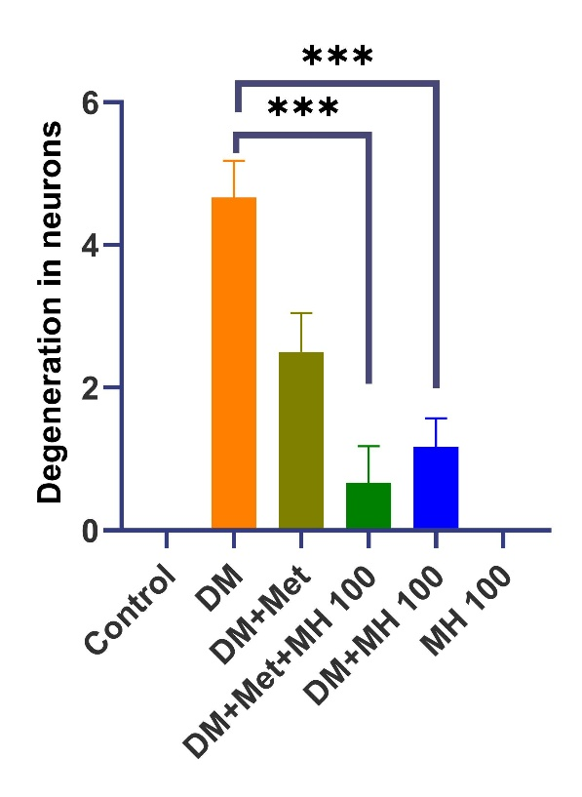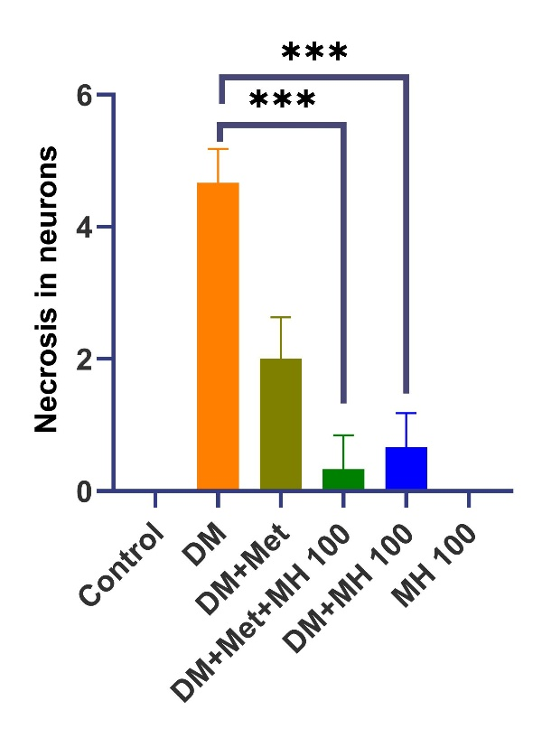

**Figure X:** Statistical analysis data of histopathological, findings seen in brain tissue. Degeneration, Necrosis (*** p <0.0001).

**3.3 Immunohistochemical Findings**

**Control group:** When brain tissues were examined immunohistochemically, GFAP expression was evaluated as negative.

**Diabetes group:** When brain tissues were examined immunohistochemically, severe GFAP expression was determined around vessels and in interstitial tissue.

**Diabetes + Metformin group:** When brain tissues were examined immunohistochemically, moderate GFAP expression was determined around vessels and in interstitial tissue.

**Diabetes + Metformin+MH 100 group:** When brain tissues were examined immunohistochemically, mild GFAP expression was determined around vessels and in interstitial tissue.

**Diabetes + MH 100 group:** When brain tissues were examined immunohistochemically, mild GFAP expression was observed around vessels and in interstitial tissue.

**MH 100 group:** When brain tissues were examined immunohistochemically, GFAP expression was evaluated as negative.

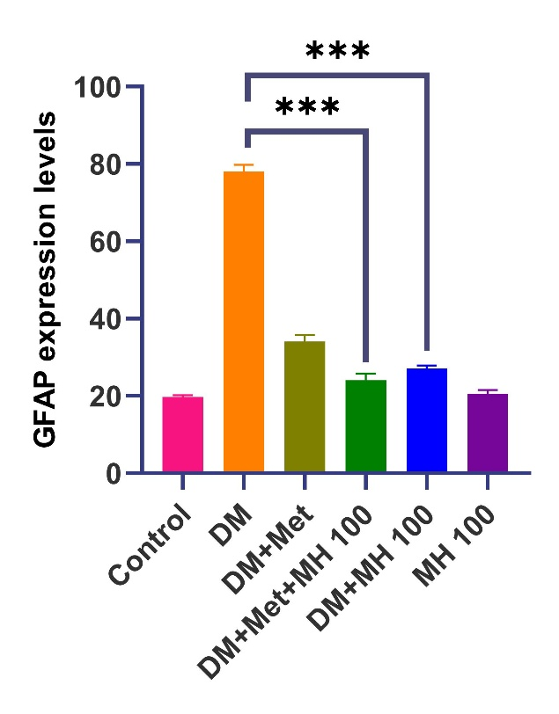

**Figure X:** Statistical analysis data of immunohistochemical finding seen in brain tissue. GFAP expression level, (*** p <0.0001).

**3.4 Immunofluorescence Findings**

**Control group:** When brain tissues were examined by immunofluorescence method, nNOS, 8-OHdG, NeuN, and H2A.X expressions were evaluated as negative.

**Diabetes group:** When brain tissues were examined by immunofluorescence method, severe nNOS, 8-OHdG, NeuN, and H2A.X expressions were observed in neurons.

**Diabetes + Metformin group:** When brain tissues were examined by immunofluorescence method, moderate cytoplasmic nNOS, 8-OHdG, NeuN, and H2A.X expressions were determined in neurons.

**Diabetes + Metformin+MH 100 group:** When brain tissues were examined by immunofluorescence method, mild cytoplasmic nNOS, 8-OHdG, NeuN, and H2a.X expressions were detected in neurons.

**Diabetes + MH 100 group:** When brain tissues were examined by immunofluorescence method, moderate cytoplasmic nNOS and H2A.X expressions, and mild cytoplasmic 8-OHdG and NeuN expressions were observed in neurons.

**MH 100 group:** When brain tissues were examined by immunofluorescence method, nNOS, 8-OHdG, NeuN, and H2a.X expressions were evaluated as negative.

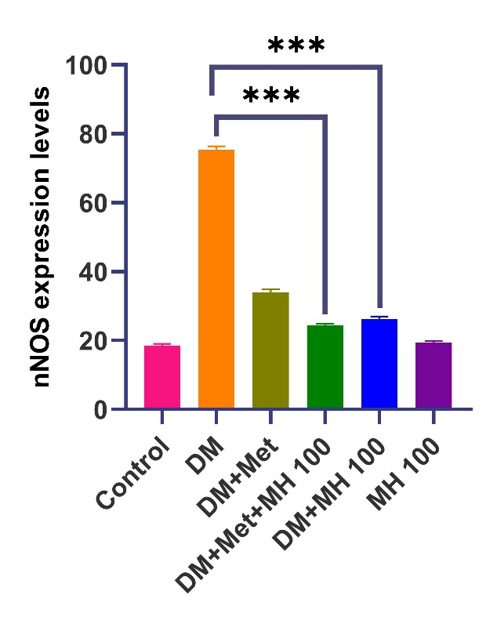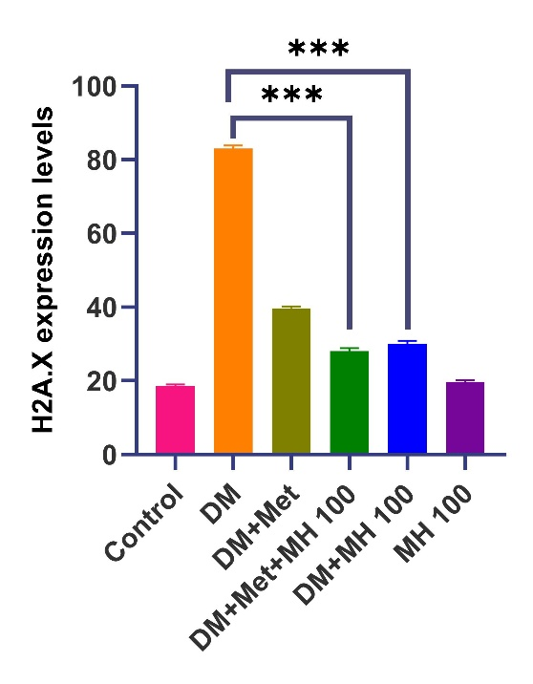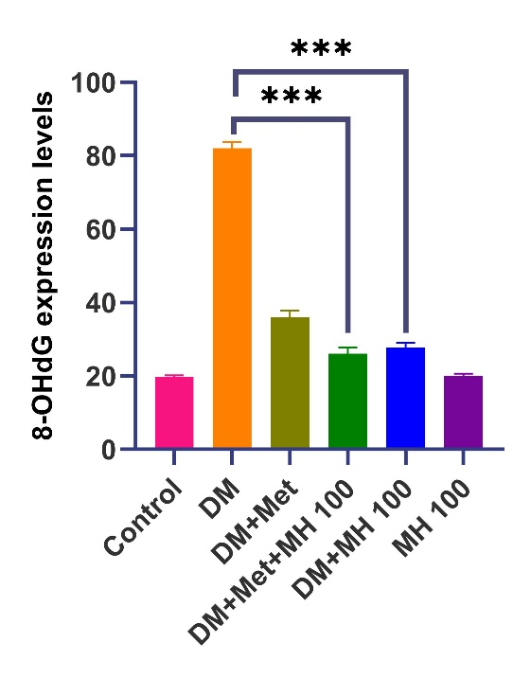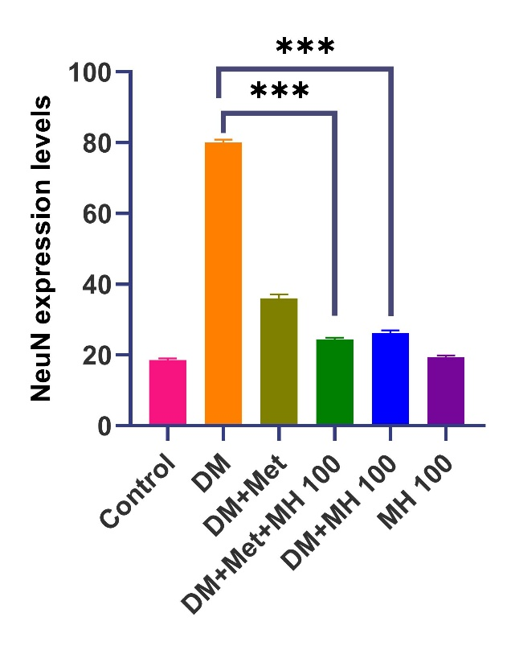

**Figure X**: Statistical analysis data of immunofluorescence findings seen in brain tissue, 8-OhdG expression level, nNOS expression level, NeuN expression level, H2A.X expression level *** (p <0.0001).

Free radicals formed due to chronic hyperglycemia cause oxidative stress by leading to deficiencies in antioxidant defense systems (18). Protection against oxidative stress includes enzymatic and non-enzymatic antioxidant systems. GSH is an important intracellular free radical scavenger, acting by balancing GSH redox homeostasis, quenching free radicals, and participating in detoxification reactions (18,19). Lipid peroxidation (LP) is one of the most important mechanisms of cell damage caused by free radicals such as ROS, leading to necrosis or apoptosis (19,20). In the present study, it was determined that MDA, SOD, GSH, neuronal nitric oxide levels that we investigated immunohistochemically, and 8-OHdG expressions, which are important markers of oxidative DNA damage, were severely increased in diabetes groups, supporting the literature information. However, it was determined that morin hydrate applications significantly reduced oxidative damage statistically. Additionally, when applied in addition to metformin, which is routinely used to reduce hyperglycemia, it was determined to have a supportive effect.

Antioxidants are substances or nutrients found in foods that can stop or delay oxidative damage in the body. Free radicals are naturally produced as oxygen is used by our body cells and can damage our tissues. As "free radical scavengers," antioxidants stop and reverse the damage caused by these free radicals. Oxidative damage is a factor in a range of health problems including cancer, diabetes, heart disease, and muscle degeneration (20). An increasing number of studies have shown that Morin Hydrate possesses different pharmacological activities including cardiovascular disease, diabetes mellitus, neurodegenerative disease, cancer, and anti-inflammatory activities. Since inflammation leads to various oxidative stress-related disorders, the antioxidant and anti-inflammatory activities of Morin Hydrate play a critical role in therapeutic processing, although the cellular mechanisms of action need to be processed (21).

Astrocytosis is defined as the large-scale activation of astrocytes that occurs to maintain homeostasis and provide trophic support due to exposure to CNS insults such as inflammation or excitotoxicity. Therefore, apoptosis can be considered a pathological marker in various neurodegenerative conditions, confirmed by upregulated GFAP. It is known that GFAP activation is activated by NFKB. Upon activation, astrocytes have been reported to initiate inflammatory reactions leading to harmful acquisitions and neuronal death (21,22). In studies, the expression of the GFAP gene in neurons against hyperglycemia has received significant attention because its onset is a marker for astrocyte development, its upregulation is a marker for reactive gliosis, and its predominance in astrocytes provides a tool for genetic manipulations (23,25). The literature on GFAP regulation is extensive because almost any disruption of development or homeostasis in the CNS is reported to cause changes in its expression (26). Studies report that NFKB expression increases due to diabetes (25,26). In this study, it was determined that NFKB expression increased in accordance with the literature information, and NFKB expression decreased in the morin hydrate applied groups. Additionally, when used in addition to metformin use, it was determined that the result approached the control group findings more closely.

**2. CONCLUSIONS**

In the study, a decrease in SOD, GSH, and GPx levels was observed as a result of increased oxidative damage due to hyperglycemia, while severe increases in MDA, NFKB, 8-OHdG, Bax, Caspase 3, and nNOS expressions were determined. It was found that the levels of these markers in morin hydrate applications approached the control group and created a statistically significant difference compared to the diabetes group. In line with these results, it was determined that morin hydrate inhibits apoptosis by reducing oxidative stress and inhibiting the neuronal inflamation and neronal damage pathway.

In conclusion, it was determined that morin hydrate exhibits protective and supportive effects against diabetes-induced neuropathy by reducing oxidative stress, inhibiting the neuronal inflamation and neronal damage pathway, and preventing neuronal apoptosis.

**References:**

1. L M Tierney, S J McPhee, M A Papadakis (2002). Current medical Diagnosis & Treatment. International edition. New York: Lange Medical Books/McGraw-Hill. ss. 1203-1215. ISBN 0-07-137688-7.
2. International diabetes federation, What is diabetes, https://idf.org/aboutdiabetes/what-is-diabetes.html Son erişim tarihi: 15 Kasım 2022.
3. IDF Diabetes Atlas, Diabetes around the world in 2021, https://diabetesatlas.org/ Son erişim tarihi: 14 Kasım 2022.
4. Özkan S, Turgay M. Tip 1-2 diabetik hastalarda psikiyatrik morbidite ve hastalıkla baş etme güçlükleri. Konsültasyon-Liyezon psikiyatrisi. 1.baskı İstanbul, 1994: 398-407.
5. Bloomgarden, Z. T. (2004). Diabetes complications. Diabetes Care, 27(6), 1506-1514.
6. Brosius, F. C., Alpers, C. E., Bottinger, E. P., Breyer, M. D., Coffman, T. M., Gurley, S. B., ... & Animal Models of Diabetic Complications Consortium. (2009). Mouse models of diabetic nephropathy. Journal of the American Society of Nephrology, 20(12), 2503-2512.
7. Garber AJ, Stein JH. Diabetes mellitus internal medicine, Mosby year book, St Lois, Missouri. 1994: 1391-92.
8. Kikkawa, R., Koya, D., & Haneda, M. (2003). Progression of diabetic nephropathy. American journal of kidney diseases, 41(3), S19-S21.
9. American Diabetes Association. (2004). Nephropathy in diabetes. Diabetes care, 27(suppl_1), s79-s83.
10. Fagrell B, Jörneskog G, Intaglietta M. Disturbed microvascular reactivity and shunting-a major cause for diabetic complications. Vascular Medicine, 1999, 4(3): 125-127.
11. Avci, S., Gunaydin, S., Ari, N. S., Karaca Sulukoglu, E., Polat, O. E., Gecili, I., ... & Taghizadehghalehjoughi, A. (2022). Cerebrolysin Alleviating Effect on Glutamate-Mediated Neuroinflammation Via Glutamate Transporters and Oxidative Stress. Journal of Molecular Neuroscience, 1-11.
12. Kilic, K., Sakat, M. S., Sahin, A., Yildirim, S., & Dortbudak, M. B. (2022). The effectiveness of berberine on noise-induced hearing loss: a rat model. Revista da Associação Médica Brasileira, 68, 1330-1336.
13. Sakat, M. S., Kılıç, K., Sahin, A., Ozmen, H. K., Yıldırım, S., Kiziltunc, A., ... & Saglam, Y. S. (2022). The protective efficacy of Quercetin and Naringenin against radiation-related submandibular gland injury in female rats: A histopathological, immunohistochemical, and biochemical study. Archives of Oral Biology, 142, 105510.
14. Gopal, J. V. (2013). Morin hydrate: botanical origin, pharmacological activity and its applications: a mini-review. Pharmacognosy Journal, 5(3), 123-126.
15. Kuzu, M., Yıldırım, S., Kandemir, F. M., Küçükler, S., Çağlayan, C., Türk, E., & Dörtbudak, M. B. (2019). Protective effect of morin on doxorubicin-induced hepatorenal toxicity in rats. Chemico-biological interactions, 308, 89-100.
16. Kuzu, M., Kandemir, F. M., Yildirim, S., Kucukler, S., Caglayan, C., & Turk, E. (2018). Morin attenuates doxorubicin-induced heart and brain damage by reducing oxidative stress, inflammation and apoptosis. Biomedicine & Pharmacotherapy, 106, 443-453.
17. Belhan, S., Yıldırım, S., Huyut, Z., Özdek, U., Oto, G., & Algül, S. (2020). Effects of curcumin on sperm quality, lipid profile, antioxidant activity and histopathological changes in streptozotocin‐induced diabetes in rats. Andrologia, 52(6), e13584.
18. Yildirim, S., Ozkan, C., Huyut, Z., & Çınar, A. (2019). Detection of Se, vit. E, vit. A, MDA, 8-OHdG, and CoQ10 levels and histopathological changes in heart tissue in sheep with white muscle disease. Biological trace element research, 188(2), 419-423.
19. Gelen, V., Şengül, E., Yıldırım, S., & Atila, G. (2018). The protective effects of naringin against 5-fluorouracil-induced hepatotoxicity and nephrotoxicity in rats. Iranian journal of basic medical sciences, 21(4), 404.
20. Yildirim, S., Celikezen, F. C., Oto, G., Sengul, E., Bulduk, M., Tasdemir, M., & Ali Cinar, D. (2018). An investigation of protective effects of litium borate on blood and histopathological parameters in acute cadmium-induced rats. Biological trace element research, 182(2), 287-294.
21. Atasoy, A., Atay, A., Ahbab, S., Hanedar, M., & Yenigün, M. (2015). Diyabetik nefropatiye genel bir bakış. Haseki Tıp Bülteni, 53(1), 16-19.
22. Sivan, S. K., & Mini, S. Antıdıabetıc Effects of Bıoflavonoıd Morın. Advances in Plant Science, 21.
23. Seçgin, Ş. (2021). Sıçanlarda Metotreksat Kaynaklı Böbrek Toksisitesi Üzerine Morinin Koruyucu Etkisi (Doctoral Dissertation).
24. Rajput, S. A., Wang, X. Q., & Yan, H. C. (2021). Morin hydrate: A comprehensive review on novel natural dietary bioactive compound with versatile biological and pharmacological potential. Biomedicine & pharmacotherapy, 138, 111511
25. Attia, M. A., Soliman, N., Eladl, M. A., Bilasy, S. E., El-Abaseri, T. B., Ali, H. S. & Zaitone, S. A. (2023). Topiramate affords neuroprotection in diabetic neuropathy model via downregulating spinal GFAP/inflammatory burden and improving neurofilament production. *Toxicology Mechanisms and Methods*, *33*(7), 563–577. <https://doi.org/10.1080/15376516.2023.2196687>
26. Brenner, M., & Messing, A. (2021). Regulation of GFAP expression. *ASN neuro*, *13*, 1759091420981206.