|  |  |  |
| --- | --- | --- |
| **E:\Academic\Syntagra\web\5-tagra_logo_2.png**  **TAGRA** | **International Congress on**  **Trends and Advances in Global Research and Applications**  21-22 Dec 2024, Erzurum  *https://congreteria.com/tagra2024* |  |

Proceedıng

**Effect of Temperature and Agitation Speed on Adsorption Activity of TiO2/PLDOPA/Fe3O4 Nanocomposite for Lead Removal**

 Hayrunnisa MAZLUMOGLU1,2\* Orcid Logo Icon of Flat style - Available in SVG, PNG, EPS, AI & Icon fonts Sule BINICI2



1 Department of Chemical Engineering, Ataturk University, 25240 Erzurum, Turkey

2 Department of Nanoscience and Nanoengineering, Ataturk University, 25240 Erzurum, Turkey

\* Corresponding author E-mail: h.mazlumoglu@atauni.edu.tr

Article Info

**Keywords**:

*Heavy metal removal*

*Lead adsorption*

*TiO2*

*Fe3O4*

*PLDOPA*

Abstract

The presence of lead in the environment poses a serious threat to ecosystems. This heavy metal is an inorganic pollutant that is non-biodegradable and toxic. The health issues associated with lead poisoning are numerous such as kidney damage, nerve damage, liver damage, infertility, miscarriages, and neonatal deaths. Due to their large specific surface area, high reactivity, and ability to remove a wide range of pollutants (1–1000 ppm) in a shorter time, nanosized adsorbents are advantageous for removing heavy metal ions. Titanium dioxide (TiO2) is one of the popular nano-metal oxide adsorbents that is employed in the remediation of organic and inorganic pollutants in wastewater due to its distinctive properties, including low toxicity, low-cost, hydrophilicity, a large surface area, and photocatalysis. Furthermore, nanosized magnetite (Fe3O4) particles are an effective means of removing heavy metals, due to their magnetic properties, large surface area, chemical stability, facile synthesis, and low toxicity. The separation of magnetic adsorbents from the aqueous medium is an easy process that can be achieved through an external magnetic field, thereby reducing secondary waste. Support materials are used to enhance the surface area of the magnetic adsorbent and prevent aggregation. As a support material, TiO2 nanowires with a large surface area were synthesized and coated with PLDOPA film, in this study. The film facilitated the deposition of Fe3O4 nanoparticles on a nanowire in a controlled manner, thereby preventing aggregation. TiO2/PLDOPA/Fe3O4 nanocomposite was employed in adsorption experiments to remove Pb+2 from aqueous medium. We investigated the effect of temperature and agitation speed on Pb+2 removal. The nanocomposite was characterized by X-ray diffraction (XRD) and transmission electron microscopy (TEM), and its adsorption activity was determined by inductively coupled plasma mass spectrometry (ICP-MS). Consequently, it was observed that the adsorption first increased and then decreased with temperature and agitation speed.

**Contents**

[1. Introduction 25](#_Toc172078896)

[2. Materials and Methods 25](#_Toc172078897)

[3. Results and Discussion 27](#_Toc172078899)

[4. Conclusion 28](#_Toc172078900)

[References 29](#_Toc172078901)

# Introduction

The rapid development of urbanization, industrialization, and agricultural practices have raised many risks in recent years. They have significant harmful effects on the environment. Among the risks is that industrial wastewater is released into the environment without being removed to meet the specified standards. Besides being highly toxic and carcinogenic, heavy metals in wastewater are also extremely stable, non-biodegradable, highly soluble, and easily transportable in aqueous medium. Due to these factors, various diseases and disorders are caused by heavy metals accumulating in living organisms. Therefore, removing heavy metals from wastewater is crucial to protecting the environment and human health (Cai et al. 2019; Al osman, Yang, and Massey 2019; Sankhla 2019).

Lead (Pb) is a heavy metal harmful even in trace amounts in wastewater. Pb is not an element the human body needs. As a result of long-term exposure to lead, many health issues can be caused, including memory loss, kidney damage, digestive problems, reproductive problems, sensory organ disabilities, irritability, dizziness, headaches, and a variety of joint and muscle problems. The United States Environmental Protection Agency (EPA) and the World Health Organization (WHO) have identified the maximum permissible limits for Pb+2 in drinking water as 0.015 ppm and 0.01 ppm, respectively (Abarikwu 2013; Rehman et al. 2019; Xu and Yoo 2020).

Heavy metal ions can be controlled by removing them from wastewater, as well as protecting the environment. Efficient, convenient, and low-cost technologies have become extremely important to remove heavy metals. The adsorption method is widely used to remove heavy metals since it offers several advantages, including easy and rapid removal, low-cost, selectivity, high activity, wide applicability, and minimal secondary pollution. In the adsorption process, it is crucial to select an appropriate adsorbent. An effective adsorbent should generally have high adsorption activity, large surface area, fast adsorption rate, and high selectivity so that it can be used to remove a large amount of pollutants rapidly (Ahmad and Azam 2019; Bashir et al. 2019).

Nanosized metal oxides as adsorbents have attracted attention in recent years. The properties of TiO2 make it an effective nanoadsorbent, including its chemical stability, large surface area, low toxicity, easy manufacture, and abundant supply. On the other hand, it has disadvantages   
such as aggregation and recovery issues. As a result of its magnetic properties, magnetite (Fe3O4) nanoadsorbents are capable of manipulating and controlling nanosized materials. In this regard, they are frequently preferred in separation processes (Ahrouch et al. 2019; Bi et al. 2019; Lei et al. 2024; Tao et al. 2020).

This study investigated the effect of temperature and agitation speed on the removal of Pb+2 through TiO2/PLDOPA/Fe3O4 nanocomposite. The production of TiO2 nanowires was carried out by the hydrothermal method, and the production of Fe3O4 nanoparticles was carried out by the solvothermal method. The TiO2 nanowires were coated with PLDOPA film and deposited with Fe3O4 nanoparticles. Nanoadsorbents exhibited large surface areas and magnetic properties allowed for easy and effective separation. As temperature and agitation speed increased, the adsorption rate increased and then decreased. A major reason is due to the contact between the adsorbent and adsorbate. The future of this study will focus on addressing other conditions that affect the adsorption of Pb+2.

# Materials and Methods

## Materials

TiO2 nanowires were produced with titanium dioxide (TiO2), sodium hydroxide (NaOH), Fe3O4 nanoparticles were produced with iron (III) chloride hexahydrate (FeCl3.6(H2O)), urea (CH4N2O), propylene glycol (C3H8O2), succinic acid (C4H6O4) and PLDOPA coatings were made with 3,4-dihydroxyphenyl-L-alanine (LDOPA), tris (hydroxymethyl) aminomethane C4H11NO3. Washing was accomplished with (HCl) and ethanol (C2H6O). All chemicals were purchased from Sigma-Aldric.

## Synthesis of Nanocomposite

TiO2/PLDOPA/Fe3O4 nanocomposite was used as an adsorbent for Pb+2 removal.

TiO2 nanowires were produced by the hydrothermal method. 1 g TiO2 was added to 40 mL, 10 M NaOH solution. It was transferred to a stainless steel reactor with a teflon chamber after stirring for 10 minutes on a magnetic stirrer. It was kept at 200 ° C for 20 hours. The reactor was cooled to room temperature and the product was washed with dilute HCl acid, deionized water, and ethanol, respectively. TiO2 nanowires were dried at 60 °C for 12 hours and stored for nanocomposite production (Mazlumoglu and Yilmaz 2021; Zhang et al. 2002).

Fe3O4 nanoparticles were produced by the solvothermal method. 3 mmol FeCl3.6(H2O), 1 mmol succinic acid, and 30 mmol urea were added to 30 mL propylene glycol. The mixture was kept in a stainless steel reactor with a teflon chamber at 200 ° C for 12 hours. A magnet was used to separate Fe3O4 nanoparticles from the product after cooling down to room temperature. The washing process was done with ethanol and deionized water, respectively. Fe3O4 nanoparticles were dried at 45 °C for 5 hours and stored for nanocomposite production (Cheng, Xu, and Gu 2011; Hou, Yu, and Gao 2003).

TiO2/PLDOPA/Fe3O4 nanocomposite was prepared as follows; 12 mg TiO2 nanowires and 4 mg Fe3O4 nanoparticles were dispersed in 60 mL tris buffer solution (10 mM, pH 8.5) and 12 mg LDOPA was added. After agitating in a shaker for 3 hours, a magnet separated the nanocomposite. After drying, the TiO2/PLDOPA/Fe3O4 nanocomposite was stored for adsorption experiments.

## Characterization Studies

Transmission electron microscope (TEM, Hitachi HighTech HT7700) and X-ray diffraction device cihazı (XRD, PANalytical Empyrean) were used for characterization studies of nanomaterials. Inductively coupled plasma-mass spectrometry (ICP-MS, Agilent 7800) determined the heavy metal removal rate. Size analysis was performed via the free software ImageJ.

## Adsorption Studies

Batch adsorption method was used to determine the effect of temperature and agitation speed on Pb2+ adsorption of TiO2/PLDOPA/Fe3O4 nanocomposite. 50 mg nanocomposite was added into 100 mL, 50 ppm Pb2+ solution. Experiments were carried out separately for 3 hours in a shaker in a dark environment at certain temperatures (298, 308, and 318 K) and agitation speeds (50, 100, and 150 rpm). The adsorbent was separated with a magnet and the amount of Pb+2 remaining in the solution was determined by ICP-MS device. To calculate the adsorption efficiency of nanocomposites, the percentage removal rate (R(%)) and the amount of adsorbed Pb+2 ( after 3 hours were calculated using Equation 1 and 2, respectively;

|  |  |
| --- | --- |
| $$R (\%)=\frac{{(C}_{0}-C_{t})x100}{C_{0} }$$ | (1) |
| $$q_{t}=\frac{{(C}_{0}- C_{t})xV}{m}$$ | (2) |

where, R (%); is the percentage removal rate of Pb+2, ve (ppm); is the concentration of Pb+2 in the solution at the beginning and after t time, $q_{t}$ (mg/g); is the amount of adsorbed Pb+2 at t time, V (L); is the volume of Pb+2 solution and m (g); is the amount of adsorbent.

# Results and Discussion

## Characterization studies

Characterization studies were carried out to determine the morphology, size, elemental distribution, and crystal structure of the nanomaterials.

Figure 1 presents TEM images at different magnifications and XRD pattern of TiO2 nanowires. TEM images in Figures 1a-b demonstrate that TiO2 nanowires were successfully synthesized. It was determined that the nanowire diameters ranged from 23 to 63 nm. In the XRD pattern in Figure 1c, diffraction peaks corresponding to the angle values of 2θ = 10.6°, 25.1°, 29.8°, 31.9°, 34.7°, 35.9°, 39°, 45.6°, 48.7°, 52.9° and 60.1° are observed. They correspond to the planes (200), (110), (003), (112), (312), (113), (004), (204), (200), (105) and (204), respectively. Furthermore, the peaks are sodium titanate (Na2Ti3O7) structures that are formed by introducing sodium ions between TiO2 nanowires and the layered titanate layers (JCPDS kart no 01-071-1169 ve 01-72–0148). This is consistent with the EDX data in Figure 1c (Ameur and Bachir 2020; Chen and Mao 2007; Yin et al. 2017).

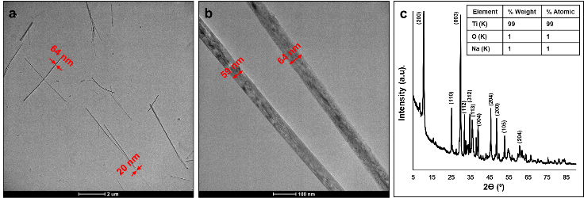

**Figure1. a-b)** TEM images at different magnifications, **c)** XRD pattern of TiO2 nanowires

Figure 2 presents TEM images at different magnifications, XRD pattern, and size distributions of Fe3O4 nanoparticles. Figure 2a and b TEM images demonstrate that Fe3O4 nanoparticles are semi-spherical in shape. A partial aggregation due to magnetic properties is also observed. Figure 2b illustrates the magnet effect on Fe3O4 nanoparticles collecting on the bottle edge. The synthesis of magnetite was successful, as demonstrated by this result. The XRD pattern is presented in Figure 2c. 2θ = 24.8°, 30.2°, 35.4°, 43°, 53.4°, 57.1°, 62.9°, 71.3° and 74.3° angles correspond to the planes (111), (220), (311), (400), (422), (511), (440), (553) and (533). These peaks are related to the specific peaks of Fe3O4 nanoparticles (JCPDS kart No 79–0418). Fe and O atoms in the table inside Figure 2c confirm the TEM images, magnetism test, and XRD pattern, which indicate magnetite formation. The graph in Figure 2d shows that nanoparticle diameters range from 3-12 nm and are more dense between 9-12 nm (El Ghandoor et al. 2012; Kharisov et al. 2012).

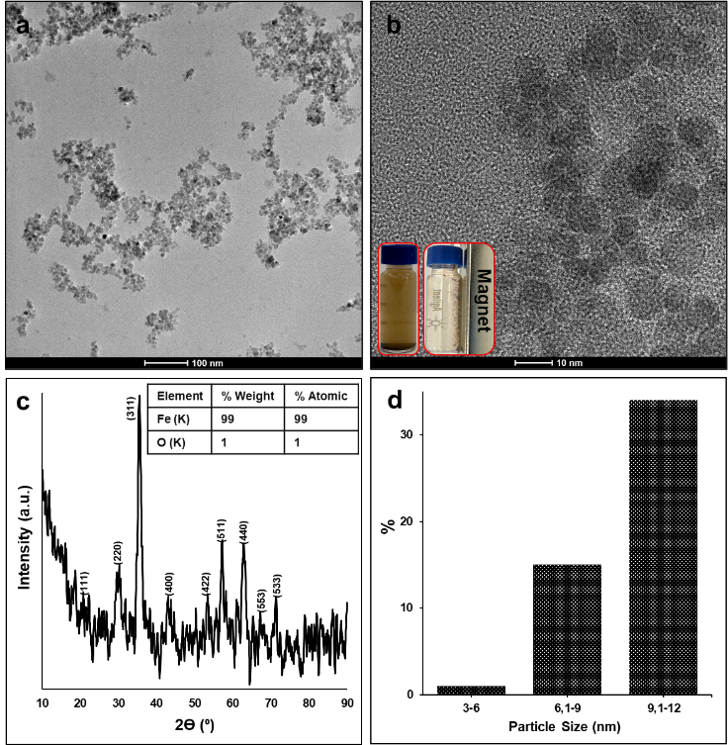

**Figure 2. a-b)** TEM images at different magnifications, **c)** XRD pattern, **d)** size distribution of Fe3O4 nanoparticles.

Figure 3 presents TEM images at different magnifications and XRD pattern of the nanocomposite. Magnetite nanoparticles have been successfully deposited on the wire as shown in Figures 3a-b. From TEM images, PLDOPA film is obvious and measured to be approximately 5 to 9 nm thick. XRD pattern in Figure 3c demonstrates that the intensity of TiO2 peaks decreases and new peaks are formed due to Fe3O4 nanoparticles. As verified by TEM and XRD results, EDX data inside Figure 3c confirm the successful deposition of Fe3O4 nanoparticles into the nanocomposite.

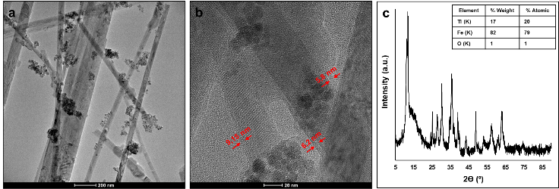

**Figure 3. a-b)** TEM images at different magnifications, **c)** XRD pattern of TiO2/PLDOPA/Fe3O4 nanocomposite

Figure 4 presents TEM images at different magnifications and XRD pattern of the nanocomposite after adsorption. Comparing Figures 3a-b and Figures 4a-b, it is observed that the dark areas of the Fe3O4 nanoparticles increase after adsorption. It can be interpreted that the dark areas are the sites of Pb+2 adsorption. XRD pattern of the nanocomposite in Figure 4c has not changed significantly after adsorption. EDX data inside Figure 4c shows a high value for Pb+2. The results confirm the adsorption of Pb+2.

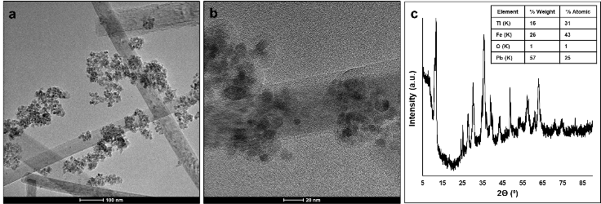

**Figure 4. a-b)** TEM images at different magnifications, **c)** XRD pattern of TiO2/PLDOPA/Fe3O4/Pb nanocomposite

## Adsorption Studies

### Effect of Temperature on Adsorption

We conducted adsorption experiments at 298, 308, and 318 K to investigate the effect of temperature on lead adsorption. The other parameters were kept constant (agitation speed; 150 rpm, adsorbent amount; 50 mg, initial lead concentration; 50 ppm and volume; 100 mL). The amount of Pb+2 remaining in solution after 3 hours was determined. Figures 5a and b show the percentage removal rate and adsorption amount of Pb+2 versus temperature, respectively. Based on Figure 5, the adsorption rate initially increases with temperature and then decreases.

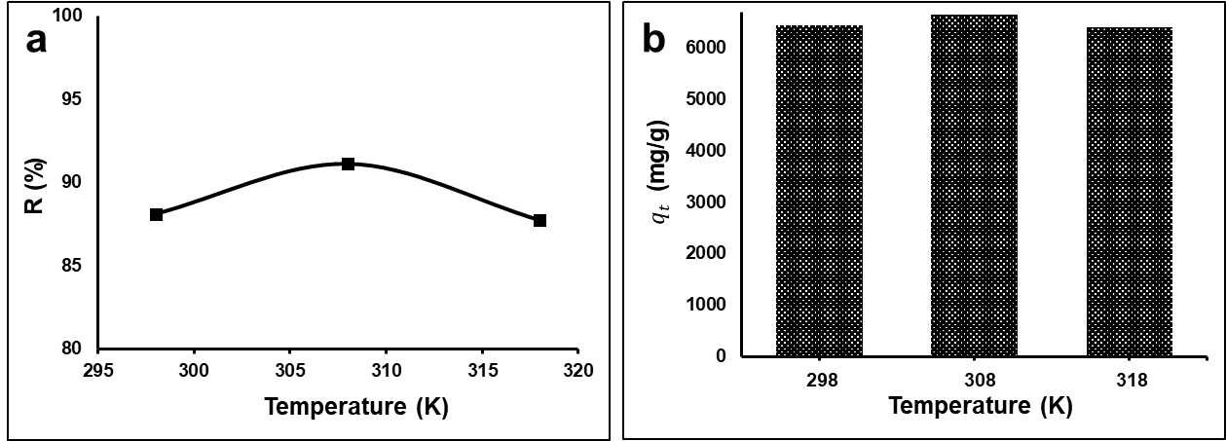

**Figure 5. a)** Percentage removal rate and **b)** amount of adsorbed Pb+2 at t time versus temperature.

During adsorption, temperature plays a significant role in thermodynamics and adsorption balance. As temperature increases, adsorption activity increases for the following reasons; i) adsorbate solubility increases, ii) liquid viscosity decreases, iii) adsorbent-adsorbate contact increases as the particle mobility increases, iv) transfer rate to the adsorbent surface increases, v) a break in internal bonds near the particle edge, and vi) the number of adsorption sites increases. The reaction rate generally increases at high temperatures, but the adsorption activity may not always increase. The adsorption activity is affected by temperature change depending on whether an exothermic or endothermic reaction occurs. Adsorption activity increases with increasing temperature when an endothermic reaction occurs, but decreases when an exothermic reaction occurs. Furthermore, increasing temperature decreases adsorption activity for the following reasons; i) adsorbate-adsorbent binding force decreases, ii) active sites number and activity decreases, and iii) adsorbate kinetic energy increases (Abdel Maksoud et al. 2020; Karapinar et al. 2023; Nassar 2010; Sobhanardakani and Zandipak 2017).

The effects of temperature in our study agree with the explanations provided above. It can be assumed that Pb+2 is adsorption onto the TiO2/PLDOPA/Fe3O4 nanocomposite in an exothermic manner.

### Effect of Agitation Speed on Adsorption

Adsorption experiments at 50, 100, and 150 rpm were conducted to study the effects of agitation speeds on lead adsorption. The other conditions were kept constant (temperature 298 K; adsorbent amount; 50 mg, initial lead concentration; 50 ppm and volume; 100 mL). A period of 3 hours was required for the experiment to reach equilibrium. The effect of agitation speed on adsorption is presented in Figure 6. The figure shows that the adsorption activity initially increased and decreased with agitation speed.

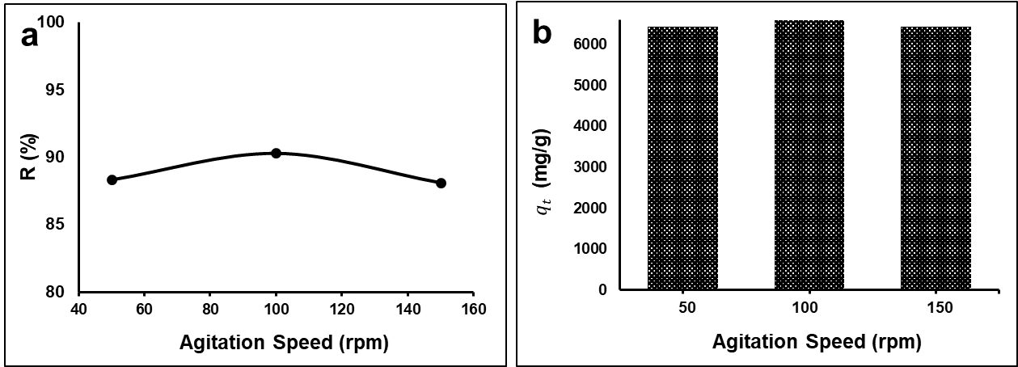

**Figure 6. a)** Percentage removal rate and **b)** amount of adsorbed Pb+2 at t time versus agitation speed.

The agitation speed plays a significant role in the adsorption process and affects the distribution of solutes. As the agitation speed increases, the adsorbate is distributed more uniformly. Also, diffusion increases with turbulence caused by agitation and a decrease in the thickness of the adsorbent boundary layer. This increases the contact between the adsorbent and the adsorbate, thereby increasing adsorption. Agitation speeds above a certain value, however, may cause vortex formation. In this manner, the contact time between the adsorbate and adsorbent decreases, and the adsorption activity decreases (Chong, Chia, and Ahmad 2013; Liang et al. 2019; Moradi et al. 2017). The results of the study can be based on these facts.

# Conclusion

In this study, TiO2@PLDOPA@Fe3O4 nanocomposite was used as an adsorbent and the effects of temperature and agitation speed on Pb+2 adsorption were investigated. Magnetic TiO2@PLDOPA@Fe3O4 nanocomposite was synthesized by depositing Fe3O4 nanoparticles on TiO2 nanowires via PLDOPA film. The nanocomposites were characterized by XRD, and TEM analysis methods before and after adsorption. The characterization results are consistent with each other. The percentage removal rate and amount of adsorbed Pb+2 were calculated based on the ICP-MS data collected before and after the adsorption experiments.

Based on the results, adsorption activity increased with temperature increase and then decreased. A rise in adsorption with temperature can be attributed to a change in the parameters that increase contact between adsorbate and adsorbent. At higher temperatures, Pb+2 adsorption can decrease due to the weakening of bonds, and an exothermic manner.

According to the results, the adsorption activity increased and then decreased with agitation speed. The rise in adsorption can be attributed to the contact between the adsorbent and the adsorbate due to an increase in turbulence and a decrease in the thickness of the adsorbent boundary layer with the agitation speed. It can be said that a vortex forms, shortening the contact time and decreasing adsorption by exceeding a certain value.

The future of this study will focus on addressing other conditions that affect the adsorption of Pb+2.

# References

Abarikwu, Sunny O. 2013. “Lead, Arsenic, Cadmium, Mercury: Occurrence, Toxicity and Diseases.” In , 351–86. http://link.springer.com/10.1007/978-3-319-02387-8\_7.

Abdel Maksoud, M.I.A. et al. 2020. “Insight on Water Remediation Application Using Magnetic Nanomaterials and Biosorbents.” *Coordination Chemistry Reviews* 403: 213096. https://linkinghub.elsevier.com/retrieve/pii/S0010854519305466.

Ahmad, Asif, and Tauseef Azam. 2019. “Water Purification Technologies.” In *Bottled and Packaged Water*, Elsevier, 83–120. https://linkinghub.elsevier.com/retrieve/pii/B9780128152720000040.

Ahrouch, Mohammadi et al. 2019. “Lead Removal from Aqueous Solution by Means of Integral Natural Clays Honeycomb Monoliths.” *Journal of Hazardous Materials* 365: 519–30. https://linkinghub.elsevier.com/retrieve/pii/S0304389418310562.

Ameur, Nawal, and Redouane Bachir. 2020. “Study of 1D Titanate‐Based Materials –New Modification of the Synthesis Procedure and Surface Properties‐Recent Applications.” *ChemistrySelect* 5(3): 1164–85. https://chemistry-europe.onlinelibrary.wiley.com/doi/10.1002/slct.201904539.

Bashir, Arshid et al. 2019. “Removal of Heavy Metal Ions from Aqueous System by Ion-Exchange and Biosorption Methods.” *Environmental Chemistry Letters* 17(2): 729–54. http://link.springer.com/10.1007/s10311-018-00828-y.

Bi, Jingtao et al. 2019. “Oil-Phase Cyclic Magnetic Adsorption to Synthesize Fe3O4@C@TiO2-Nanotube Composites for Simultaneous Removal of Pb(II) and Rhodamine B.” *Chemical Engineering Journal* 366: 50–61. https://linkinghub.elsevier.com/retrieve/pii/S1385894719302347.

Cai, Li-Mei et al. 2019. “Heavy Metal Contamination and Health Risk Assessment for Children near a Large Cu-Smelter in Central China.” *Science of The Total Environment* 650: 725–33. https://linkinghub.elsevier.com/retrieve/pii/S0048969718335186.

Chen, Xiaobo, and Samuel S. Mao. 2007. “Titanium Dioxide Nanomaterials: Synthesis, Properties, Modifications, and Applications.” *Chemical Reviews* 107(7): 2891–2959. https://pubs.acs.org/doi/10.1021/cr0500535.

Cheng, Changming, Fangjie Xu, and Hongchen Gu. 2011. “Facile Synthesis and Morphology Evolution of Magnetic Iron Oxide Nanoparticles in Different Polyol Processes.” *New Journal of Chemistry* 35(5): 1072. https://xlink.rsc.org/?DOI=c0nj00986e.

Chong, H.L.H., P.S. Chia, and M.N. Ahmad. 2013. “The Adsorption of Heavy Metal by Bornean Oil Palm Shell and Its Potential Application as Constructed Wetland Media.” *Bioresource Technology* 130: 181–86. https://linkinghub.elsevier.com/retrieve/pii/S0960852412018408.

El Ghandoor, H., H.M. Zidan, Mostafa M.H. Khalil, and M.I.M. Ismail. 2012. “Synthesis and Some Physical Properties of Magnetite (Fe3O4) Nanoparticles.” *International Journal of Electrochemical Science* 7(6): 5734–45. https://linkinghub.elsevier.com/retrieve/pii/S1452398123196556.

Hou, Yanglong, Junfeng Yu, and Song Gao. 2003. “Solvothermal Reduction Synthesis and Characterization of Superparamagnetic Magnetite NanoparticlesElectronic Supplementary Information (ESI) Available: Size Distributions of Samples Modified with TOPO + PVP, HDA + PVP, and PVP Only. See Http://Www.Rsc.Org.” *Journal of Materials Chemistry* 13(8): 1983. https://xlink.rsc.org/?DOI=b305526d.

Karapinar, Hacer Sibel, Fevzi Kilicel, Faruk Ozel, and Adem Sarilmaz. 2023. “Fast and Effective Removal of Pb(II), Cu(II) and Ni(II) Ions from Aqueous Solutions with TiO2 Nanofibers: Synthesis, Adsorption-Desorption Process and Kinetic Studies.” *International Journal of Environmental Analytical Chemistry* 103(16): 4731–51. https://www.tandfonline.com/doi/full/10.1080/03067319.2021.1931162.

Kharisov, Boris I. et al. 2012. “Iron-Containing Nanomaterials: Synthesis, Properties, and Environmental Applications.” *RSC Advances* 2(25): 9325. https://xlink.rsc.org/?DOI=c2ra20812a.

Lei, Yuanhang et al. 2024. “Advances in Adsorption of Pb(II) by MOFs-Based Nanocomposites in Water.” *Progress in Natural Science: Materials International* 34(1): 122–46. https://linkinghub.elsevier.com/retrieve/pii/S1002007124000480.

Liang, Xue Xue et al. 2019. “Efficient Adsorption of Pb(II) from Aqueous Solutions Using Aminopropyltriethoxysilane-Modified Magnetic Attapulgite@chitosan (APTS-Fe3O4/APT@CS) Composite Hydrogel Beads.” *International Journal of Biological Macromolecules* 137: 741–50. https://linkinghub.elsevier.com/retrieve/pii/S0141813019319828.

Mazlumoglu, Hayrunnisa, and Mehmet Yilmaz. 2021. “Silver Nanoparticle-Decorated Titanium Dioxide Nanowire Systems via Bioinspired Poly( l -DOPA) Thin Film as a Surface-Enhanced Raman Spectroscopy (SERS) Platform, and Photocatalyst.” *Physical Chemistry Chemical Physics* 23(23): 13396–404. http://xlink.rsc.org/?DOI=D1CP01322J.

Moradi, Atefeh, Peyman Najafi Moghadam, Reza Hasanzadeh, and Mika Sillanpää. 2017. “Chelating Magnetic Nanocomposite for the Rapid Removal of Pb(II) Ions from Aqueous Solutions: Characterization, Kinetic, Isotherm and Thermodynamic Studies.” *RSC Advances* 7(1): 433–48. https://xlink.rsc.org/?DOI=C6RA26356A.

Nassar, Nashaat N. 2010. “Rapid Removal and Recovery of Pb(II) from Wastewater by Magnetic Nanoadsorbents.” *Journal of Hazardous Materials* 184(1–3): 538–46. https://linkinghub.elsevier.com/retrieve/pii/S030438941001085X.

Al osman, Muwaffak, Fei Yang, and Isaac Yaw Massey. 2019. “Exposure Routes and Health Effects of Heavy Metals on Children.” *BioMetals* 32(4): 563–73. http://link.springer.com/10.1007/s10534-019-00193-5.

Rehman, Mahfooz-ur et al. 2019. “Adsorption Mechanism of Pb2+ Ions by Fe3O4, SnO2, and TiO2 Nanoparticles.” *Environmental Science and Pollution Research* 26(19): 19968–81. http://link.springer.com/10.1007/s11356-019-05276-x.

Sankhla, Mahipal Singh. 2019. “Contaminant of Heavy Metals in Groundwater & Its Toxic Effects on Human Health & Environment.” *International Journal of Environmental Sciences & Natural Resources* 18(5). https://juniperpublishers.com/ijesnr/IJESNR.MS.ID.555996.php.

Sobhanardakani, Soheil, and Raziyeh Zandipak. 2017. “Synthesis and Application of TiO2/SiO2/Fe3O4 Nanoparticles as Novel Adsorbent for Removal of Cd(II), Hg(II) and Ni(II) Ions from Water Samples.” *Clean Technologies and Environmental Policy* 19(7): 1913–25. http://link.springer.com/10.1007/s10098-017-1374-5.

Tao, Yu, Chuan Zhang, Ting Lü, and Hongting Zhao. 2020. “Removal of Pb(II) Ions from Wastewater by Using Polyethyleneimine-Functionalized Fe3O4 Magnetic Nanoparticles.” *Applied Sciences* 10(3): 948. https://www.mdpi.com/2076-3417/10/3/948.

Xu, Yue, and Ik-Keun Yoo. 2020. “Removal of Lead from Water Solution by Reusable Magnetic Adsorbent Incorporating Selective Lead-Binding Peptide.” *Applied Sciences* 10(18): 6418. https://www.mdpi.com/2076-3417/10/18/6418.

Yin, Ling et al. 2017. “Synthesis of Layered Titanate Nanowires at Low Temperature and Their Application in Efficient Removal of U(VI).” *Environmental Pollution* 226: 125–34. https://linkinghub.elsevier.com/retrieve/pii/S0269749117300507.

Zhang, Y.X. et al. 2002. “Hydrothermal Synthesis and Photoluminescence of TiO2 Nanowires.” *Chemical Physics Letters* 365(3–4): 300–304. https://linkinghub.elsevier.com/retrieve/pii/S0009261402014999.